 |  |  | 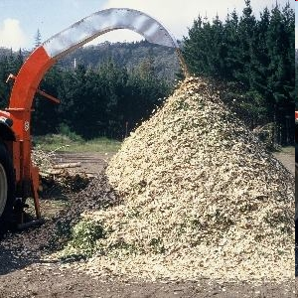  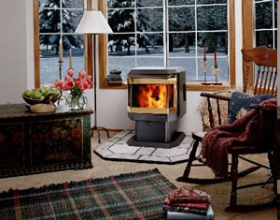    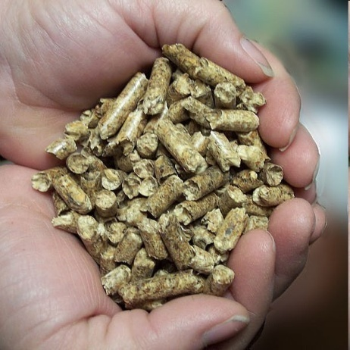
Life Cycle Analysis and Implementation of
Renewable Fuel Standard Thermal Pathways
for Wood Pellets and Chips
LCA.6161.209.2020
September 9, 2020

Prepared by:
Stefan Unnasch
Lucy Buchan

DISCLAIMER

This report was prepared by Life Cycle Associates, LLC under contract with Technology Transition Corporation, on behalf of the Biomass Thermal Energy Council (BTEC). Life Cycle Associates is not liable to any third parties who might make other use of this work. No warranty or representation, express or implied, is made with respect to the accuracy, completeness, and/or usefulness of information contained in this report beyond the above stated use. Finally, no liability is assumed with respect to the use of, or for damages resulting from the use of, any information, method or process disclosed in this report beyond the above stated use. In accepting this report, the reader agrees to these terms.

ACKNOWLEDGEMENT

Life Cycle Associates, LLC performed this study under contract to Technology Transition Corporation (TTC). Peter Thompson, Project Coordinator, is the primary contact person for TTC.

Contact Information:

Stefan Unnasch
Life Cycle Associates, LLC
1.650.461.9048
unnasch@LifeCycleAssociates.com
www.LifeCycleAssociates.com

Peter Thompson
Technology Transition Corporation, Biomass Thermal Energy Council
1.202.457.0868 x302
pthompson@ttcorp.com
www.ttcorp.com | www.biomassthermal.org

Recommended Citation: Unnasch. S. and L. Buchan (2020). Life Cycle Analysis and Implementation of Renewable Fuel Standard Thermal Pathways for Wood Pellets and Chips, Life Cycle Associates Report LCA.6161.1.2019, Prepared for Technology Transition Corporation.
Contents
Executive Summary 7
1. Introduction 8
1.1 Background 8
1.2 Regulation for Biofuels and Biomaterials 8
1.3 Renewable Fuel Standard (Federal) 9
1.4 Feedstock Options 12
1.5 Sustainable Biomass Production 14
1.6 Greenhouse Gases and Climate Change 15
1.6.1 The Greenhouse Effect 15
1.6.2 Greenhouse Gases 15
1.6.3 Wildfire Risk 15
1.6.4 Climate Change 17
1.7 Goal and Scope Definition 18
1.8 Life Cycle Assessment Background 19
1.8.1 Upstream Life Cycle Data 20
1.9 Study Contents 21
2. Methods and Data 22
2.1 System Boundary 22
2.1.2 Life Cycle Analysis 25
2.2 Scenarios for GHG Impacts 31
2.3 Data Sources 32
2.3.1 Wood Pellets and Chips Production Energy Inputs 32
2.3.2 Heating Oil and Natural Gas Upstream Emissions 36
3. LCA Results 38
3.1 Wood Pellets and Chips LCA 38
3.2 Heating Oil and Natural Gas LCA 40
3.3 Scenario Analysis 40
4. Carbon Credit Programs 42
4.1 California Low Carbon Fuel Standard 42
4.2 Voluntary Credit Programs 43
4.3 Renewable Fuel Standard 43
5. Conclusions 45
Appendices 50

Tables

Table 1. Product Definitions Under the RFS2. 10
Table 2. RIN Pathways for Cellulosic Feedstocks 11
Table 3. Alternative Fuel Volumes – Actual, Statutory, Proposed, and Finalized 12
Table 4. RFS-Compliant Biomass Feedstocks for Wood Pellets and Wood Chips 13
Table 5. Sources of Biomass under RFS 14
Table 6. Global Warming Potential of GHG Pollutants 16
Table 7. Life Cycle Models and Databases Used for Wood Pellet Production 20
Table 8. Feedstock Fertilizer Inputs. 32
Table 9. GREET Data for Diesel Consumption for Wood Feedstock 33
Table 10. Diesel Inputs for Forestry and Estimates for Lumber Mill Operations. 33
Table 11. Woody Biomass Feedstock Parameters for Transport to Pelletizing Plants and Associated GHG Emissions. 36
Table 12. GREET Upstream Emissions for Heating Oil and Natural Gas. 37
Table 13. GHG Emissions of Wood Pelletsª 38
Table 14. GHG Emissions of Wood Chips 38
Table 15. GHG Emissions of Heating Oil and Natural Gas 40
Table 16. Comparison of Valuation of Woody Biomass Fuel as Heating Fuel Under the RFS and as Process Fuel Under the LCFS. 44

Figures

Figure 1. Locations of wood pellet mills in North America. 12
Figure 2. The RFS2 prohibits the use of forest residue from tree plantations on federal land. This prohibition, as stated, does not exclude the use of thinnings and residues from non-tree-plantation federal lands 14
Figure 3. Particulate emissions associated with heating fuels. 17
Figure 4. Process Framework for Life Cycle Assessment 19
Figure 5. System Boundary Diagram for Life Cycle Assessment (damaged forests include infested trees or trees killed by pests such as bark beetle). 22
Figure 6. Wood pellet feedstock sourcing. 24
Figure 7. Biomass pelletization process. 24
Figure 8. Pellet plant costs. 24
Figure 9. Carbon Balance for biofuels and fossil fuels. 27
Figure 10. Incremental carbon storage (in tonnes) for a forest stand scenario compared to fossil fuel combustion. 29
Figure 11. Incremental carbon storage and associated emissions in sustainably harvested forests. 30
Figure 12. Relative moisture content of different states of woody biomass. 34
Figure 13. GHG Emissions of Wood Pellets and Wood Chips from specified woody biomass feedstocks. 39
Figure 14. CI of Heating Oil and Natural Gas and their Renewable Alternatives. 41
Figure 15. Performance targets for the California Low Carbon Fuel Standard. 42
Figure 16. Price (USD) per ton for credits generated by the California Low Carbon Fuel Standard. 43
Figure 17. Value of renewable identification number (RIN) credits generated under the Renewable Fuel Standard. 44

Terms and Abbreviations

ANL Argonne National Laboratory
ARB California Air Resources Board
Btu British Thermal Unit
CA California
CI Carbon intensity
CO Carbon monoxide
CO₂ Carbon dioxide
CO₂e Carbon dioxide equivalent
EPA U.S. Environmental Protection Agency
g CO₂e Grams of carbon dioxide equivalent
GHG Greenhouse Gas
GREET The Greenhouse gas, Regulated Emissions, and Energy use in
Transportation model
GWP Global Warming Potential
LCA Life Cycle Analysis or Life Cycle Assessment
LCFS Low Carbon Fuel Standard
LHV Lower Heating Value
MJ MegaJoule
MMBtu Million Btu
N₂O Nitrous oxide
NG Natural gas
NOx Oxides of nitrogen
RIA Regulatory Impact Analysis
RFS2 Revised Federal Renewable Fuels Standard
RPS Renewable Portfolio Standard
VOC Volatile Organic Compound
WTT Well-To-Tank
WTW Well-To-Wheels (or Wake)

Executive Summary
Biomass Thermal Energy Council (BTEC) and the United States Department of Agriculture (USDA) Forest Service are examining the possibility of adding biomass thermal conversion as a fuel pathway to Renewable Fuel Standard (RFS). This Study evaluates the usage of wood chips and wood pellets as substitutes for fossil heating oil and natural gas for the northeastern U.S.

Currently, the EPA RFS2 does not include a fuel pathway for woody biomass as a heating fuel; however, the rule includes numerous pathways that use biomass, including forest residue, as feedstock to produce liquid biofuels which replace fossil fuels. Woody biomass itself is a source of energy if burned in residential wood stoves or industrial boilers, and can reduce greenhouse gas (GHG) emissions if substituted for fossil fuels such as heating oil and natural gas. Since woody biomass is categorized under the RFS2 as a renewable source of energy, when sustainable forest practices are used, and its use results in significantly lower GHG emissions compared to fossil fuels, the use of biomass as a heating fuel under the RFS2 would be consistent with the application of the rule.

Moreover, since heating oil from cellulosic biomass has a defined pathway under RFS (L, D7) (Table 2), and wood pellets and wood chips are substitutes for fossil heating oil, woody biomass replacing heating oil or natural gas should qualify for a pathway under the RFS2.

The GHG emissions of wood pellets and wood chips produced from various sources including, lumbermill waste, forest residue, urban wood waste, pine beetle-infested, and pulp wood were estimated using Argonne National Laboratories’ GREET1_2019 model to determine upstream life cycle inputs. The treatment of sustainable forestry practices was also examined.

The life cycle GHG emissions for biomass fuels ranges from 10 to 18 g CO₂e/MJ depending on factors including feedstock source. The emissions associated with pellet fuel represent approximately 3% of this fuel’s energy value. The GHG emissions of natural gas and heating oil, two predominant fuels used for residential heating in the northeastern U.S., were calculated using GREET1_2019, as well as the older version of GREET (_1.8c) that was used in the RFS2 regulatory impact analysis. In comparison to these conventional heating fuels, biomass fuels result in a 85-120% reduction in GHG emissions, which exceeds the 60% GHG reduction requirement for cellulosic biofuels under the RFS2 (Zhang et al., 2015).

Since wood pellets/chips meet the GHG reduction targets under the RFS, are often made from waste biomass from lumbermills, construction debris, forest residue, and landscape trimmings, and have a significantly lower CI compared to heating oil and natural gas, it is recommended that EPA reevaluate the RFS and consider creating a pathway for thermal conversion of biomass as residential heating energy. Recent bipartisan legislation introduced in 2019 by U.S. Senator Ron Wyden, D-Oregon proposes to allow the use of biomass waste from certain federal lands for making renewable fuels, indicating congressional support for this recommendation.

Introduction
The Biomass Thermal Energy Council (BTEC) and the United States Department of Agriculture (USDA) Forest Service made an agreement to assess the implications of adding biomass thermal conversion as a fuel pathway to the Renewable Fuel Standard (RFS). The scope of the agreement is to promote usage of sustainably harvested wood chips and wood pellets as substitutes for fossil heating oil and natural gas.

Life Cycle Associates, LLC was contracted to complete a life cycle analysis of the greenhouse gas (GHG) emission impacts (this Study) associated with utilizing woody biomass (pellets and chips) for thermal energy applications. The alternative fuel use is heating oil or natural gas. This Study includes the following four sections:

1) Quantify life cycle GHG emissions associated with using woody biomass feedstocks currently eligible under the Renewable Fuel Standard (RFS) for use in thermal energy applications. Two pathways are considered: wood chipped directly from eligible feedstocks, and wood pellets produced from eligible feedstocks;
2) Quantify life cycle greenhouse gas emissions associated with using fossil fuels for thermal energy applications. Two fuels are considered: natural gas and heating/fuel oil;
3) Compare the life cycle greenhouse gas emissions for the woody biomass thermal applications with those of the fossil fuels considered; and
4) Compare the greenhouse gas benefits/impacts of these pathways for using eligible woody biomass feedstocks to those already approved for Renewable Identification Number (RIN) generation in the RFS.

Background
Recently, agriculture and forestry have emerged as potential mechanisms to meet U.S. energy demands and to address resource and climate change concerns through biomass-based energy. The potential benefits, such as increased domestic energy security, reduced GHG emissions, and increased support for rural and agricultural economic development, have focused the attention of industry, policymakers, and the environmental and scientific communities on the development of biomass-based energy. Since agriculture, forestry, and energy production all have significant impacts on resources and the environment, developing sustainable production methods and consumption patterns in each of these sectors is critical.

Regulation for Biofuels and Biomaterials
Use of biofuels is on the rise in the United States. An important driver of the increased use of biofuels in the United States is the federal and state level regulations and tax incentives that have been passed over the past decades. The Federal Renewable Fuel Standard program was created to reduce greenhouse gas emissions and expand the renewable fuels sector while reducing reliance on fossil fuels.

Renewable Fuel Standard (Federal)
The Renewable Fuel Standard (RFS) was signed into law under the Energy Policy Act of 2005, and was expanded through the Energy Independence and Security Act of 2007 (EISA). The RFS program establishes requirements for the amount of renewable fuel that must be blended into on- and off-road petroleum fuels, with the dual goals of increasing energy independence and reducing climate change impacts. The RFS legislation falls under the Clean Air Act (CAA), and the Environmental Protection Agency (EPA) has the responsibility of setting annual renewable standard amounts. The RFS2, the current set of regulations enacted in 2007, requires the use of 36 billion gallons of renewable fuel annually by 2022 in the United States, 21 billion of which must be non-cornstarch ethanol biofuels such as cellulosic biofuel or biomass-based diesel. It required the use of 16.55 billion gallons of renewable fuel in 2013, 1.28 billion gallons of which had to be biomass-based diesel substitutes. However, production of cellulosic biofuels has so far been well below required levels (EIA, 2012; EPA, 2020).

Under the RFS2, gasoline and diesel fuel refiners and importers are required to purchase a certain amount of renewable fuels annually. This is called their Renewable Volume Obligation. In order to verify that their obligations have been met, refiners must submit renewable fuel credits to the EPA. These tradable credits are called Renewable Identification Numbers (RINs), which are generated through the production of biofuels. One RIN corresponds to 1 gallon of ethanol equivalent. RINs are generated when renewable fuels can be shown to achieve a certain percentage reduction in life cycle greenhouse gas emissions as compared to a petroleum fuel baseline. The emissions are measured in terms of kilogram of emissions per MJ of fuel, commonly known as a fuel’s carbon intensity (CI). The required reduction percentage varies by biofuel. Currently, this percentage is 20% for corn ethanol, 50% for advanced biofuels, and 60% for cellulosic biofuels. Table 1 shows the official RFS definitions for the renewable fuels covered in the regulation.

Table 1. Product Definitions Under the RFS2.
Products | RFS2 Definition
Advanced biofuel | a renewable fuel, other than ethanol derived from cornstarch, that has life cycle greenhouse gas emissions that are at least 50 percent less than baseline life cycle greenhouse gas emissions.
Biomass-based diesel | a renewable fuelª that has life cycle greenhouse gas emissions that are at least 50 percent less than baseline life cycle greenhouse gas emissions and meets all of the requirements of paragraph (1) of this definition:  (i) Is a transportation fuel, transportation fuel additive, heating oil, or jet fuel.  (ii) Meets the definition of either biodiesel or non-ester renewable diesel.  (iii) Is registered as a motor vehicle fuel or fuel additive under 40 CFR part 79, if the fuel or fuel additive is intended for use in a motor vehicle.
Biodiesel | a mono-alkyl ester that meets ASTM D 6751 (incorporated by reference, see §80.1468).
Cellulosic biofuel | a renewable fuel derived from any cellulose, hemi-cellulose, or lignin that has life cycle greenhouse gas emissions that are at least 60 percent less than the baseline life cycle greenhouse gas emissions.
Cellulosic diesel | any renewable fuel which meets both the definitions of cellulosic biofuel and biomass-based diesel, as defined in this section 80.1401. Cellulosic diesel includes heating oil and jet fuel made from cellulosic feedstocks.
Renewable gasoline blendstock | a blendstock made from renewable biomass that is composed of only hydrocarbons and which meets the definition of gasoline blendstock in §80.2(s).
Non-ester renewable diesel (NERD) | A renewable fuel which is all of the following:  (1) A fuel which can be used in an engine designed to operate on conventional diesel fuel, or be heating oil or jet fuel.  (2) Not a mono-alkyl ester.
ª Note that a renewable fuel that is co-processed with petroleum is not considered to be biomass-based diesel.

Each batch of renewable fuel is assigned a unique identifier that applies to a given calendar year and producer, and this is its renewable identification number (RIN). A batch can be any volume less than 1 million gallon-RINs. A RIN is assigned to a batch of fuel at the time when its ownership is being transferred (EPA, 2012).

Table 2 describes several pathways for cellulosic biofuels (table excerpted from 40 CFR 80.146) made from waste byproduct feedstocks that would otherwise decompose and produce GHG or might be repurposed into lower-value products such as landscaping material. As the RFS endorses converting vegetative waste streams into high-value home heating oil (HHO) in exchange for the highest-value RIN (D3), it logically follows that cellulosic feedstock such as slash, pre-commercial thinnings, and tree residue ought to be similarly endorsed under the RFS for the purpose of heating homes via cellulosic (wood) pellets. In the U.S., wood pellets and cord wood account for approximately 2 percent of the primary residential space heating fuel (Voegele, 2019). The Northern Forest Region of New England is well-situated to support switching to wood pellet heat (Buchholz et al., 2017). The region is also well-suited to support the use of wood chips.

Table 2. RIN Pathways for Cellulosic Feedstocks
Path | Fuel Type | Feedstock | Production Process Requirements | D-Code
L | Cellulosic diesel,  jet fuel and heating  oil. | Cellulosic biomass from crop residue, slash, pre-commercial thinnings and tree residue, annual cover crops, switchgrass, miscanthus, energy cane Arundo donax and Pennisetum purpureum; cellulosic components of separated yard waste; cellulosic components of separated food waste; and cellulosic components of separated municipal solid waste (MSW). | Any
  7 (cellulosic biofuel or biomass-based diesel)
M | Renewable gasoline  and renewable  gasoline  blendstock. | Cellulosic biomass from crop residue, slash,  pre-commercial thinnings and tree residue, annual cover crops; cellulosic components of separated yard waste; cellulosic components of separated food waste; and  cellulosic components of separated MSW. | Must utilize natural gas,  biogas, and/or biomass as the only process  energy sources | 3 (cellulosic biofuel)

Currently, under the EPA RFS2 there is no fuel pathway for burning biomass, however, there are numerous pathways that use biomass, including forest residue, as feedstock to produce biofuels that replace fossil fuels. Biomass itself is a source of energy. When burned in residential wood stoves or boilers, or industrial boilers as a substitute for fossil fuels, it can reduce GHG emissions. Sustainable forest management practices enable the monitoring and verification of best harvesting practices. Since biomass-based fuel qualifies as a renewable feedstock under the RFS (
Table 3), its use for heating would be consistent with RIN generation under the RFS2. Moreover, since heating oil from cellulosic biomass has a defined pathway under the RFS (L, D7) (Table 2), and wood pellets and wood chips are substitutes for fossil heating oil, their treatment as an additional fuel under pathway L would also follow.
Table 3. Alternative Fuel Volumes – Actual, Statutory, Proposed, and Finalized
Fuel Category | Fuel Volumes (Billion Gallons/year)
Fuel Category | 2019 | 2020 | 2020 | 2020 | 2021
Fuel Category | Actual | Statutory | EPA Proposed | EPA Final | EPA Final
Cellulosic biofuel | 0.42 | 10.5 | 0.54 | 0.59 | n/a
Biomass-based diesel | 2.1 | ≥1.0 | n/a | 2.43 | 2.43
Advanced biofuel | 4.92 | 15 | 5.04 | 5.09 | n/a
Renewable fuel | 19.92 | 30 | 20.04 | 20.09 | n/a

Feedstock Options
Wood pellets and wood chips are two common forms of biomass fuels. Wood pellets are primarily used for residential and small commercial heating, while wood chips are used for commercial and institutional heating. Wood pellet mills are located throughout North America and are most abundant in the eastern third of the U.S. (Figure 1). Wood pellets and wood chips are made from various sources, however, in order to comply with RFS and generate RINs, biomass used in the process should be from one of the sources listed in Table 4.

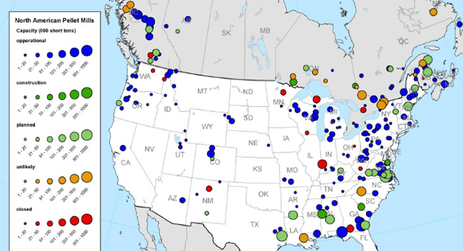
Figure 1. Locations of wood pellet mills in North America.
Source: Thran et al., 2017.

Table 4. RFS-Compliant Biomass Feedstocks for Wood Pellets and Wood Chips
Feedstock | Source | Land Type per RFS | Current Fate
Clean sawdust from sawmill and planning mills | Planted treesª | Non-federal forestland | MDF/particleboard/  wood pellets/animal bedding/mulch/energy
Clean sawdust from furniture industry | Planted treesª | Non-federal forestland | Pellets, mulch, landfill, energy
Salvaged material (insect/disease, ice storms, wind events), fire hazard reduction | Pre-commercial thinnings/  salvage harvest | Non-federal forestland | Firewood/hog fuel/ decomposing to CO₂
Logging residue | Slash/pre-commercial thinnings/  planted trees | Non-federal forestland | On site burning/ hog fuel/slash piles/ firewood
Urban wood waste (UWW)^{b} |  | Non-federal lands | Landfilling/composting/ mulch
Hardwood and softwood pulpwood | Planted and naturally regenerated trees | Non-federal lands | Pulp and paper
ªTrees and tree residue from actively managed tree plantations on non-federal land cleared at any time prior to December 19, 2007 (US EPA, 2010). These are primarily located in VA, GA, and SC.
^{b}The portion of the wood waste stream that can include sawn lumber, pruned branches, stumps, and whole trees from street and park maintenance. The primary constituents of UWW are used lumber, trim, shipping pallets, trees, branches, and other wood debris from construction and demolition clearing and grubbing activities (CalRecycle.ca.gov/condemo/wood, 2020).

The source of woody biomass feedstock falls into two main categories: wood residue and harvested trees. According to the RFS, in order to use harvested trees from tree plantations for bioenergy purpose, the biomass must be obtained from non-federal lands (Table 4 and Table 5). While the prohibition (Figure 2) on removal of slash and residue from non-plantation (natural forest) federal lands is unclear, slash and wood residue generate GHG through decomposition, planned burns, and wildfires. As demonstrated in this Study, were EPA to interpret the collection of slash and tree residues from federal lands as allowable under the RFS, such residues could have alternative fates involving more favorable climate effects.

Cellulosic residues are defined under the RFS, and include planted trees from actively managed tree plantations on non-federal land. The regulatory impact analysis EPA (2010) defines a tree plantation as a stand of no less than one acre composed primarily of hand-planted or machine-planted trees, however, trees originating from natural seeding by mature trees growing on a plantation can also be categorized as renewable biomass. Therefore, EPA’s definition excludes materials from forests in the Lake States, Northern New England, Central Appalachians, and other regions that are managed to allow natural tree regrowth. Including managed forests in the RFS would require revisions to its definition of renewable biomass. Converting planted tree residue to wood pellets, however, may generate stakeholder concern due to net carbon balance, or indirect land use conversion.
Table 5. Sources of Biomass under RFS
Category | Federal Land | Non-Federal Land
Slash/Residue from tree plantation | No | Yes
Natural Forests | TBD | Yes
Harvest from plantations | No | Yes, if planted before 2007^{b}
ª The RFS rule explicitly prohibits the use of tree residue from tree plantations on federal land. This exclusion
does not prohibit the use of tree residue from natural forests such as those damaged by bark beetles.
^{b} Definition of plantation varies by region.

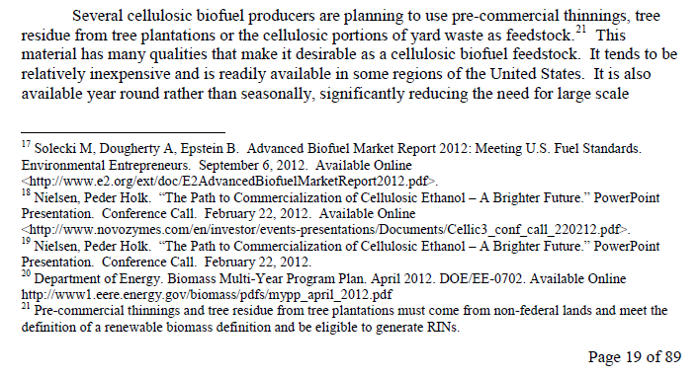
Figure 2. The RFS2 prohibits the use of forest residue from tree plantations on federal land. This prohibition, as stated, does not exclude the use of thinnings and residues from non-tree-plantation federal lands
Source: EPA, 2013.

Sustainable Biomass Production
The use of woody biomass for energy purposes has been increasing in recent decades, implying the importance of woody resources in sustainable economies, due to opportunities
to replace consumption of fossil fuel with renewable resources and reduce GHG emissions (Quinteiro et al., 2019). While some argue that harvesting woody biomass for bioenergy production endangers biodiversity and reduces carbon stock in forests, several studies have shown that harvesting biomass from sustainably managed forest lands for bioenergy purposes not only reduces the GHG emission by reducing fossil energy usage but also increases the carbon stock in forests (Dale et al. 2017; Kim et al. 2018; IEA Bioenergy, 2018).

Dale et al. (2017) studied the impact of wood-based pellet production on forest conditions in the southeastern United States by using the U.S. Department of Agriculture Forest Service (USFS) Forest Inventory and Analysis (FIA) annual survey data for 2002–2014. In this study two fuelsheds including Chesapeake, Virginia, and Savannah, Georgia were assessed. The results showed that production of wood-based pellets in the southeast US enhances GHG sequestration. In another study, Kim et al. (2018) evaluated the impact of growth in biomass demand on global forests and concluded that bioenergy expansion can drive forest resource investment at the intensive and extensive margins, resulting in a net increase in forest carbon stocks for most regions of the world, including the U.S.

Greenhouse Gases and Climate Change

The Greenhouse Effect
The greenhouse effect is a natural process that results in warmer temperatures on the surface of the earth than that which would occur without it. The effect is due to concentrations of certain gases in the atmosphere that trap heat as infrared radiation from the earth is reradiated back to outer space. The greenhouse effect is essential to the survival of most life on earth, by keeping some of the sun’s warmth from reflecting back into space and sustaining temperature that make the Earth livable (Myhre et al., 2013).

Greenhouse Gases
The gases emitted globally that contribute to the greenhouse effect are known as greenhouse gases (or GHG). Primary GHG include water vapor, carbon dioxide (CO₂), methane (CH₄), nitrous oxide (N₂O), and other trace gases. Natural sources of GHG include biological and geological sources such as plant and animal respiration, forest fires and volcanoes. However, industrial sources of GHG are the primary concern. The GHG of primary importance are CO₂, CH₄, and N₂O because they represent the majority of the GHG emitted by industry. Because CO₂ is the most abundant of these gases, GHG are usually quantified in terms of CO₂ equivalent (CO₂e), based on the relative longevity in the atmosphere and the related global warming potential (GWP).

Wildfire Risk
The increase in the size and acreage burned by wildfires, particularly in the Western US, is another risk of great concern associated with climate change (Congressional Research Service, 2019). Although wildfire is not a factor in the RFS, it effectively displaces wood combustion, and therefore is factored into this analysis as an alternative fate. Recent bark beetle infestations (Collins et al., 2012) and drought (Stephens et al., 2018) have also resulted in widespread tree mortality and caused concern regarding the associated increased fuel load Increased fuel load, via climate change and disease, have increased wildfire risk creating a concern that wildfires are inevitable, and that a pragmatic solution of harnessing this fuel load into predictable and useable fuel sources is a good idea. Wildfires result in much higher methane emissions than combustion in a stove and presumably less than decomposition.

Global Warming Potential
GWP is a measure of the potential of a gas to have an effect that could lead to climate change due to prolonged residence time in the atmosphere. The GWP can be used to quantify and communicate the relative and absolute contributions to climate change of emissions of different GHG (Myhre et al., 2013) and of emissions from countries or sources. Table 6 shows the GWP values from the Intergovernmental Panel on Climate Change (IPCC), an international body founded by the United Nations for the 100-year and 20-year time horizons from the two latest IPCC Assessment Reports, (AR4 and AR5), about the state of scientific, technical and socio-economic knowledge on climate change.

Table 6. Global Warming Potential of GHG Pollutants
IPCC Assessment | AR5ª |  | AR4^{b}
GWP Time Horizon | 100 | 20 | 100 | 20
CO₂ | 1 | 1 | 1 | 1
CH₄ | 30ª | 85 | 25ª | 72
N₂O | 265 | 264 | 298 | 289
ª IPCC Fifth Assessment Report 5 (AR5) published in 2014 includes a GWP of 28 for biogenic CH₄. Since the biogenic source would be emitted either as CO₂ or CH₄, the difference between the GWP of 30 and 28 represents in the indirect effects of methane decomposition to CO₂. (Myhre, 2013)
^{b} Fourth IPCC Assessment report published in 2007

The United Nations Framework Convention on Climate Change uses the 100-year GWP. The United States primarily uses the 100-year GWP for reporting of GHG emissions. The State of Washington Greenhouse Gas Reporting program (Section 173-441 of the Washington Administrative Code) also uses the 100-year GWP. The 20-year GWP is sometimes used as an alternative to the 100-year GWP. The 20-year GWP prioritizes gases with shorter lifetimes, because it does not consider impacts that happen more than 20 years after the emissions occur. Because all GWPs are calculated relative to CO₂, emission calculations based on a 20-year GWP will be larger for gases with lifetimes shorter than that of CO₂, and smaller for gases with lifetimes longer than CO₂ (EPA). Values in this Study are based on the AR4 100-year GWP for consistency with International and United States reporting requirements.

In addition to more well-known GHG gases, including carbon dioxide, nitrous oxide, and methane, the GREET model is also configured with particulate matter and black carbon emissions on a life cycle basis. The AR4 values with zero GWP for black carbon were used in the 2010 EPA Regulatory Impact Analysis (RIA) for Air Pollution Regulations. This Study will examine the sensitivity of the GWP factors. Particulate emissions from wood combustion, including black carbon, are a concern for local air quality, as shown in Figure 3.

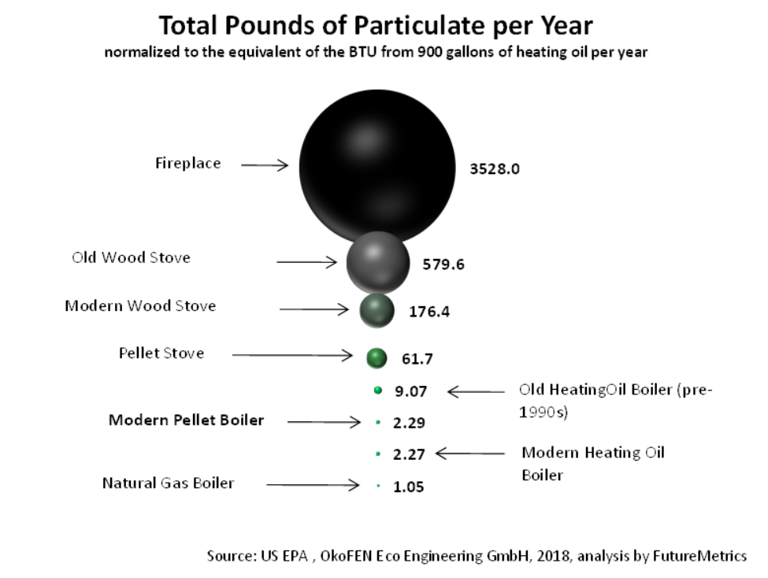
Figure 3. Particulate emissions associated with heating fuels.
Source: analysis by FutureMetrics using US EPA and OkoFEN data

Climate Change
The phenomena of natural and human-caused effects on the atmosphere that cause changes in long-term meteorological patterns due to global warming and other factors is generally referred to as climate change. The global climate changes continuously, as evidenced by repeated episodes of warming and cooling documented in the geologic record. But the rate of change has typically been incremental, with warming or cooling trends occurring over the course of thousands of years. The past 10,000 years have been marked by a period of incremental warming, as glaciers have steadily retreated across the globe. However, scientists have observed an unprecedented increase in the rate of warming over the past 150 years (IPCC, 2018). This recent warming has coincided with the Industrial Revolution, which resulted in widespread deforestation to accommodate development and agriculture along with increasing use of fossil fuels. These changes in land uses and consumption of fossil-based, carbon-laden fuels have resulted in the release of substantial quantities of greenhouse gases – to the extent that atmospheric concentrations have reached levels unprecedented in the modern geologic record.

The accumulation of GHG in the atmosphere affects the earth's temperature. While research has shown that the Earth's climate has natural warming and cooling cycles, the overwhelming preponderance of evidence indicates that emissions related to human activities have elevated the concentration of GHG in the atmosphere far beyond the level of naturally-occurring concentrations, and that this, in turn, is resulting in more heat being held within the atmosphere. The IPCC has concluded that it is "very likely" – representing a probability of greater than 90 percent – that human activities and fossil fuels, commonly referred to as anthropogenic emissions, explain most of the warming over the past 50 years (IPCC 2018).

The IPCC (2018) predicts that under current human GHG emission trends, the following results could be realized within the next 100 years:
- global temperature increases between 1.1 to 6.4 degrees Celsius;
- potential sea level rise between 18 to 59 centimeters or 7 to 22 inches
- reduction in snow cover and sea ice;
- potential for more intense and frequent heat waves, tropical cycles and heavy precipitation; and
- impacts to biodiversity, disease outbreaks, drinking water and food supplies.

The Climate Impacts Group (CIG) is a Washington State-based interdisciplinary research group that collaborates with federal, state, local, tribal, and private agencies, organizations, and businesses, and studies impacts of natural climate variability and global climate change on the Pacific Northwest. CIG research and modeling (2013) indicates the following possible impacts of human-based climate change in the Pacific Northwest:
- changes in water resources, such as decreased snowpack, earlier snowmelt, decreased water for irrigation, fish and summertime hydropower production, increased conflicts over water, and increased urban demand for water;
- changes in salmon migration and reproduction;
- changes in forest growth and species diversity and increases in forest fires; and
- changes along coasts, such as increased coastal erosion and beach loss due to rising sea levels, increased landslides due to increased winter rainfall, permanent inundation in some areas, and increased coastal flooding due to sea level rise and increased winter stream flows.

GHG affect climate change in the same manner irrespective of the location of emissions, and the impacts on climate are felt globally. Emissions from combustion as a wood stove fuel in the Northeast, or as decomposition of forest material, have the same affects as those from any other location. While general consensus is that anthropogenic GHG emissions are a cause of climate change, it is the cumulative effect of all emission sources in the atmosphere rather than individual sources that is the cause. It is not generally possible to equate a specific climate change response to a specific emissions source from an individual project.

Goal and Scope Definition
The goal of this Study is to quantify the GHG emissions associated with burning wood pellets and wood chips as alternatives for heating oil and natural gas used for home heating purpose. This Study also compares the life cycle GHG emissions for the woody biomass thermal applications with those of the fossil fuels. As part of EPA’s 2010 Regulatory Impact Analysis (RIA) of the Renewable Fuel Standard (RFS), it conducted a life cycle assessment (LCA) of the biofuels specified in RFS2 using GREET_1.8c. Therefore, GHG emissions of wood pellets and wood chips are examined using GREET1_2019 (the most recent version of GREET) as well as GREET_1.8c.

Life Cycle Assessment Background
Since the effect of GHG emissions occur over a long duration, the life cycle and total global emissions are considered the relevant metric. Life Cycle Assessment (LCA) is a technique used to model the environmental impacts associated with the production of a good. LCA models can assess environmental impacts over a range of categories, including GHG emissions as well as others. This is done by taking a full inventory of all the inputs and outputs involved in a product’s life cycle. This Study takes a partial LCA approach by identifying GHG emissions associated with burning woody biomass, heating oil and natural gas for home heating purposes.

Upstream emission are calculated on a life cycle basis to enable the calculation of cradle to grave emissions in combination with direct or end-use emissions, which is consistent with the ISO 14040 methodology (ISO, 2006). The upstream life cycle emissions correspond to the Scope 2 and Scope 3 emissions that are part of statewide inventory reporting (World Resources Institute, 2004).

Most LCA tools are spreadsheet or database models that use life cycle inventory (“LCI”) data to calculate the environmental impacts associated with the material flows and inputs. Additionally, LCA has been used to support regulatory and/or legislative initiatives for renewable targets, such as targets for GHG emission reductions. This Study follows the process for Life Cycle Assessment defined by international standards shown in Figure 4.

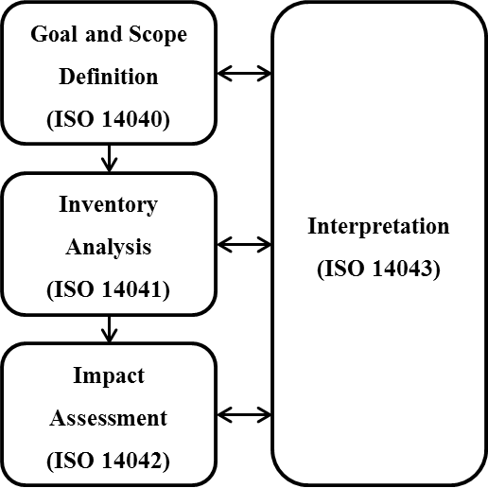
Figure 4. Process Framework for Life Cycle Assessment
Source: (ISO, 2006)

Life cycle emissions are generally considered to cover the full life cycle from resource extraction to end use. Life cycle assessments are generally limited to the manufacturing, construction and operation periods. An LCA includes the upstream emissions for inputs to a process. In most cases, upstream emissions occur in the production of upstream inputs. For example, producing the natural gas used for generation of electric power on site requires upstream energy inputs. Upstream energy inputs like these are accounted for in this Study.

The boundaries of life cycle emissions typically expand beyond the regional scope of a region such as the Northeast. The production of feedstocks and materials can occur outside the region even if facility operations occur in the state. Global life cycle emissions represent an appropriate metric for GHG emissions because of the long-lasting effect of the pollutants, however, emissions that occur in the Northeast are of interest due to the common practice of using heating oil for home heating purpose.

Determining life cycle emissions for all of the project-related inputs requires an iterative analysis of these components. Several LCA models have been developed to perform these calculations for fuels and materials as shown in Table 7. All the models include life cycle data for various products, including natural gas and diesel fuel used in pellet processing.

Table 7. Life Cycle Models and Databases Used for Wood Pellet Production
Year | Organization | Location of Use | Scope of Products | Model/ Database | Citation
2009 | NESCCAF | USA | Residential Heating | GREET 1.8b | (Unnasch and Riffel, 2009)
2015 | University College Dublin | Ireland | Residential Heating | SimaPro/  Ecoinvent | (Murphy et al., 2015)
2017 | USDA | USA | Residential Heating | SimaPro/ USLCI | (Brackley et al., 2017)
2019 | CESAM | Portugal | Residential Heating | Ecoinvent | (Quinteiro et al., 2019)

Upstream Life Cycle Data
In this Study, the GREET_2019 model was used to calculate the GHG emissions of wood pellets and wood chips as well as heating oil and natural gas. GREET is a publicly available, peer-reviewed Life Cycle Analysis (LCA) model that provides transparency to calculations. GREET was developed by Argonne National Laboratory with support from several programs in the U.S. Department of Energy’s Office of Energy Efficiency and Renewable Energy, including the Bioenergy Technologies Office, Vehicle Technologies Office, and Fuel Cell Technologies Office. GREET is structured to systematically examine the well-to-wheels (WTW) energy use and emissions associated with a wide range of vehicle technologies and feedstock sources for producing alternative fuels, and can be used to estimate emissions associated with non-transportation fuels, such as wood pellets and wood chips, because the emissions associated with woody feedstocks apply across different types of fuels derived from them. The number of woody biomass feedstocks included in GREET models continues to expand over time. The GREET models themselves do not provide specifics of harvesting practices and other environmental practices associated with woody feedstocks, however, the upstream inputs and associated emissions in GREET are based on the assumption that biogenic CO₂ emissions emitted through biofuel combustion are offset by atmospheric carbon uptake during biomass growth, thereby assuming carbon neutrality of biogenic carbon. The GREET model documents emissions associated with forest residue removal, urban demolition wood, and energy-crop harvested trees. The GREET model is also used in the Renewable Fuel Standard (RFS2) Final Rule to estimate the GHG emissions of various biofuels. The GREET model provides the basis for upstream life cycle inventory (LCI) data for this Study.

Study Contents
This Study examines the effect of replacing heating oil and natural gas with wood pellets and woodchips on global GHG emissions, and includes the following sections:

- Introduction
- Methods and Data
- LCA Results
- Sustainability Assessment
- Conclusions

Section 1 provides an introduction to the woody biomass, GHG emissions, and LCA. The methods and data used in the Study are described in Section 2, which includes a description of upstream fuel cycle inputs, as well as the energy inputs for wood pellet and chip production and other data. Section 3 takes the data in Section 2 and estimates the environmental impacts of wood pellets and chips used in residential heating and compares them with those of heating oil and natural gas. Section 4 provides an overview of current sustainability programs in the US. Section 5 summarizes the conclusions of this Study.

Methods and Data
This Study examines the GHG emissions for wood pellets and wood chips used in residential heating. The emissions from wood pellets and chips are compared to the GHG emissions from petroleum heating oil and natural gas. This section describes the system boundary for the analysis, the approach for calculating life cycle emissions, scenarios considered in the Study, and data sources. The discussion of the approach describes a summary of the activity in each step of the life cycle and calculation methods. Since many of the data sources are common among life cycle stages, the discussion is grouped according to the type of emissions that occur.

System Boundary
The analysis of GHG emissions for woody biomass includes emissions associated with feedstock collection/production and transportation, the production of process fuels, the delivery of the product to the market, and burning the fuels. It is performed on a life cycle basis. Upstream emissions include natural gas feedstock extraction, processing and transmission as well as imported grid power. Downstream emissions consist of transport and distribution emissions from delivering wood pellets and chips to the market. The system boundary for wood pellets and wood chips is shown in Figure 5. There are four reference systems in the system boundary which implies the fate of each biomass source.

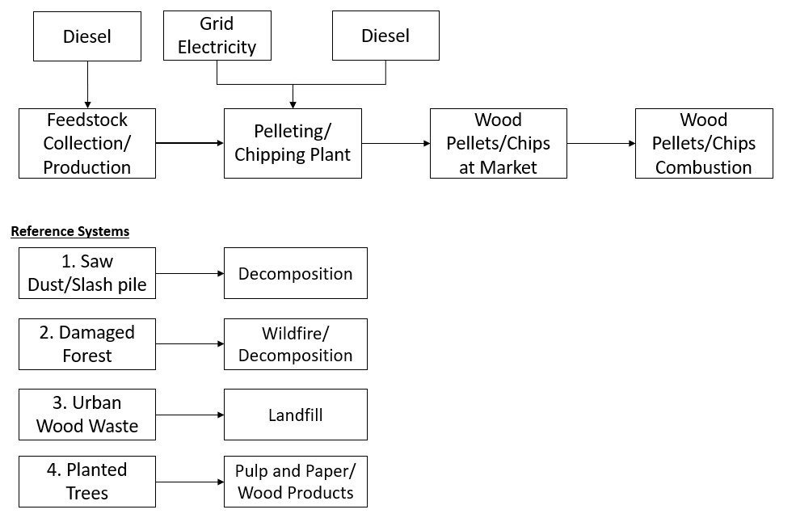
Figure 5. System Boundary Diagram for Life Cycle Assessment (damaged forests include infested trees or trees killed by pests such as bark beetles).
Since both heating oil and wood pellets are more commonly used for residential heating in New England than in other parts of the U.S., this study accounts for transport of pellets derived from feedstocks located in the western and southeastern U.S. to New England.

Woody Biomass Processing Description
This section provides a brief overview of the steps required to convert raw material woody biomass into woodchips and pellets.

Feedstock collection/transportation/production
The amount of energy consumed to collect and transport woody biomass feedstock varies depending on a number of factors, including whether the source is from urban or forested areas, whether it is chipped in the field or transported to a chipping mill, the distance traveled from source location to either storage facility or chipping/pellet mill, and the type of fuel used to power the in-field chippers, transportation vehicles, as well as equipment in the chipping facilities, including forklifts and chipping machines. Emissions associated with renewable power sources will be lower than for conventional fossil-based fuels, such as diesel.

Transport Distances
Typically finished product wood chips and pellets require two phases of transport: distance travelled from the feedstock source to a chipping or pelleting plant, and distance travelled from the chipping or pelleting plant to market. In some cases, woody biomass feedstock may be chipped at the source location, for example, within a forest, and shipped directly to market.

Pelletization Process
The biomass pelletization process consists of multiple steps including raw material preparation, pelletization and post-treatment. Feedstock preparation includes selecting suitable feedstock, filtration to remove unwanted materials, debarking and chipping, storing excess material, drying, cutting feedstock to appropriate size in a hammer mill, pelletizing, cooling, packaging, and shipping (Figure 7).
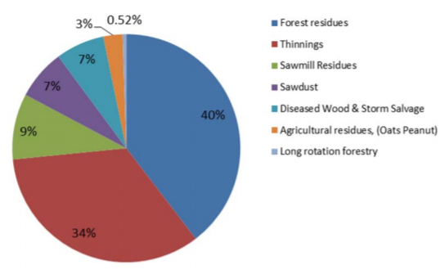
Figure 6. Wood pellet feedstock sourcing.
Source: Drax, 2014.
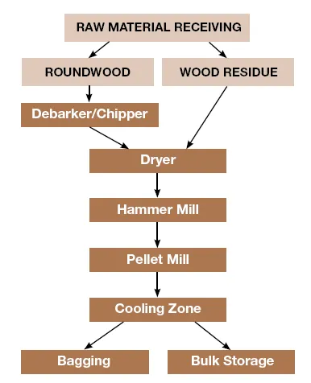
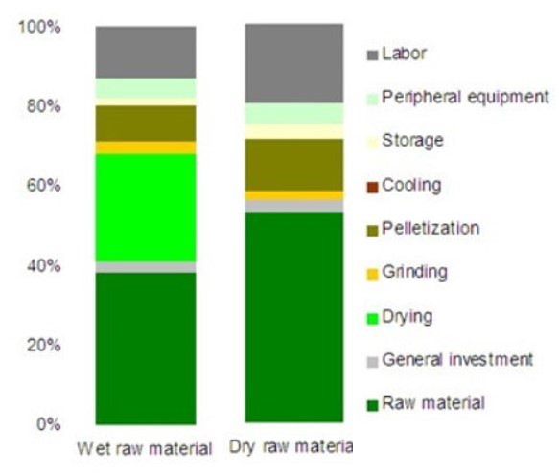
The moisture content (MC) in biomass feedstock can vary greatly. For example, freshly cut forest residue and urban tree removal/trimmings are typically about 50% moisture, ranging from 35-60% depending on vegetation type and time of year when harvesting occurs (Badger, 2002). Moisture content at time of transportation from source area is typically 45% (Argonne National Labs, 2019). Drier biomass feedstocks include insect-infested forest residue (10 – 16% MC (for lodgepole pine, Page et al., 2014)) and used lumber, shipping pallets, and construction debris (12 - 15% MC (Donovan, 1994)). The maximum moisture content permissible for wood to be used as a fuel is in the range of 65 to 68 percent (Badger, 2002). Above this moisture content, the energy required to evaporate the moisture is greater than the energy in the dry matter of wood, and combustion cannot be sustained without a supply of external energy. Therefore, feedstock moisture content is an important parameter to consider in operations and to factor into an LCA, as it needs to be reduced to 10 to 15% prior to pelletization. The wood pellet product moisture content is typically 8 – 10% (Pellet Fuels Institute, 2020).
Figure 7. Biomass pelletization process.
Source: Zafar, 2020.
Figure 8. Pellet plant costs.
Source: Huang, 2013.
The feedstock drying process is energy intensive and can account for 70% of the total energy used in the pelletization process, and approximately 25% of the cost to run a pellet plant (Figure 8). Rotary drum dryers are the most common equipment used for this purpose. A typical industrial-level wood pellet mill has the capacity to run two rotary dryers (Biomass Magazine, 2020). Superheated steam dryers, flash dryers, spouted bed dryers and belt dryers can also be used. Drying increases the efficiency of biomass and produces virtually no smoke on combustion. Feedstock chipping comprises a considerable portion of a plant’s processing energy. A typical industrial pellet plant is equipped with approximately two 1,200 horsepower (hp) chipper lines, and ten 400 hp hammer mills (Biomass Magazine, 2020).

Functional Unit
The functional unit for the Study is 1 MJ of useful thermal energy (e.g., lower heating value, LHV) delivered for residential heating. The life cycle emissions are analyzed over this functional unit. The emissions are also reported per tonne of wood pellets/chips delivered to the market.
The RFS calculates GHG emission for 1 million Btu of fuel (MMBtu) on an LHV basis. The metric of one mega-Joule is more commonly used today. Fuels that generate credits under the RFS are counted as renewable identification numbers (RINs), with 1 RIN being equivalent to 77,000 Btu of denatured ethanol.

Life Cycle Criteria
This Study determines the GHG emissions from fuel combustion and fugitive emissions including CO₂, CH₄, and N₂O. Other GHG emission sources include unburned and fugitive methane and nitrous oxide (N₂O) from fuel combustion. As discussed in Section 1.6.2, CO₂ emissions correspond to fully oxidized fuel per the reporting method used in the RIA.
GHG emissions include numerous components, some of which cause local pollution, for example black carbon, characterized as either coarse particulate matter (PM _{10-2.5}) or fine (PM _{2.5}). PM standards are established by US EPA (2012). While black carbon is calculated in the GREET modeling system, it is not a criterion under the RFS. Therefore, even though black carbon has GHG impacts, these are not counted in the RFS or other fuel programs, and are not examined in this Study.

Life Cycle Analysis
Life cycle emissions generally consist of direct and upstream life cycle emissions. Argonne National Laboratory’s (2019) GREET model has been extensively used for quantification of life cycle emissions associated with fuels and other products. This Study uses the GREET framework to calculate emission rates from cradle to gate (ANL, 2019).

Each step in the life cycle analysis includes direct and upstream life cycle emission rates (E_{u}). Upstream life cycle emission rates include a variety of energy inputs and emissions, including natural gas, petroleum fuels, and electric power. Emission rates (E_{i}) for each step in the life cycle are calculated from the specific energy (S_{i}), direct emission factor (EF_{i}), and upstream emission rates for the step such that:

E_{i} = S_{i} × (EF_{i} + E_{ui}) (1)

Where:
E_{i} = Life Cycle Emission rate for Step i
EF_{i} = Emission Factor for Step I, for each type of equipment and fuel
S_{i} = Specific Energy for Step i
E_{ui} = Upstream life cycle emission rate for fuel i
Typically, GHG calculations are tracked on a specific energy basis. For example, the term S_{i} for natural gas use is represented in MMBtu/tonne of woody biomass in this Study. The emission factor (EF) depends upon the carbon content of fuel as well as CH₄ and N₂O emissions for the type of equipment. For electric power, the term EF is zero but upstream emissions are calculated using the same principles. The terms EF and E represent a data array that includes CO₂, CH₄ and N₂O emissions.

Upstream life cycle emission rate (E_{u}) depends on the energy inputs and emissions for each fuel or material, and are calculated in the same manner as shown in Equation 1. Upstream emissions for this Study are calculated using the GREET model with inputs described in Section 2.3.

Carbon Balance
Carbon Balance in GREET
The carbon balance for biofuels is well documented with the treatment of biofuels under the RFS2 and LCFS. Short cycle carbon is absorbed from the atmosphere by living plant biomass and converted to cellulose that is used to produce biofuels, which are combusted, releasing CO₂ to the atmosphere. The net carbon flux is accounted for through the analysis of indirect land use conversion (ILUC) associated with harvested biomass. Therefore, both ethanol or home heating oil (HHO) derived from cellulosic biomass conversion, are treated as carbon neutral fuels.

In contrast, fossil fuel-based products utilize carbon that has been stored underground for millions of years (Figure 9). With the accounting system in GREET, fermentation emissions are calculated as net zero. The emissions from fuel combustion for most liquid fuels, including HHO, are comparable at 72 g CO₂/MJ; however, the short cycle carbon is not included in the WTW reporting for the RFS2, LCFS, and the Renewable Energy Directive (RED). The carbon factor for natural gas (55 g CO₂/MJ), is lower than for HHO, and for wood, it ranges from 90 to 95 g CO₂/MJ.

This life cycle analysis assumes that emissions associated with conversion of woody biomass to wood pellets are on a net carbon neutral basis, reflecting that biogenic CO₂ is removed from the atmosphere with no storage effect. While biogenic uptake and reforestation, as well as changes in forest growth do occur, they are not explicitly included in this model, and are treated as net zero, consistent with the RFS.

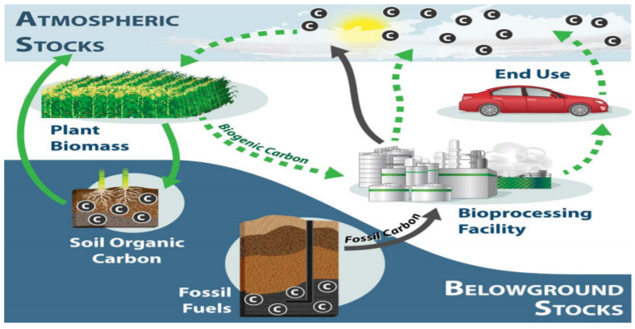
Figure 9. Carbon Balance for biofuels and fossil fuels.
Source: Kim, 2013.

Carbon Storage Policies and Voluntary Sustainability Certifications
Policies encouraging the development of forest biomass energy generally consider biomass to be a carbon neutral energy source by accounting for the carbon emissions as part of a natural cycle, wherein they are captured over time through forest growth. The following subsection of this Study briefly describes how different carbon accounting methods may challenge this assumption.

Forest certification is a voluntary market-based approach designed to recognize sustainable forest management by labeling forest and the wood products from those forests as being managed under certified standards. Various certification programs exist including those managed through the Sustainable Forest Initiative (SFI), the Forest Stewardship Council (FSC), the Roundtable on Sustainable Biofuels (RSB-F), the Roundtable on Sustainable Biomaterials (RSB-M), and the Program for the Endorsement of Forest Certification (PEFC). SFI standards are commonly used in the U.S and include measures to protect water quality, biodiversity, wildlife habitat, species at risk and forests with exceptional conservation value. The standard is for any organization in the United States or Canada that owns or manages forests. FSC principles and criteria provide a foundation for forest management standards globally, and include the US Forest Management Standard (V1.0) for forest management certification in the U.S. The RSB-F has recognized FSC forest management standards and certifications since 2013, after concluding that principles and criteria from FSC and RSB standards were aligned. In most cases, therefore, FSC-certified forests are considered to be in compliance with RSB-F’s principles and criteria. In a comparison of forest certification programs, Garzon et al. (2020) found the FSC to be more detailed and prescriptive in nearly all aspects considered for forest certification.

Forest management certifications are intended to provide environmental, social, and economic benefits to forest landowners who choose to become certified. Sustainable certification, however, is not required by the RFS, and does not influence RFS pathways; a sustainable certification does not assure compliance with the RFS, and vice versa.

Alternative Methods of Carbon Accounting
Comparisons of GHG from different fuel sources can vary depending on the bioenergy combustion technology and fossil fuel technology employed, the biophysical and forest management characteristics of the forests from which biomass is harvested, and the starting point of the analysis. Forest carbon accounting results that are based on a static stand-level versus a dynamic forest landscape management approach, will greatly differ. As illustrated below, a single stand-level analysis will reflect a carbon debt-then-dividend that occurs over a longer timeframe than a dynamic carbon balance for a managed forest landscape.

Using a stand-level approach, Walker et al. (2013) showed that during the initial period of forest growth, approximately 32 years, GHG emissions from forests exceeded those of energy-equivalent fossil fuel combustion, accumulating carbon debt in these forest systems. Thereafter, forest GHG decreased incrementally in relation to fossil fuel combustion, yielding carbon dividends in the respective forest systems (Figure 10). They also found that replacing fossil fuels in thermal or combined heat and power (CHP) applications typically has lower initial carbon debts than do utility-scale biomass electric plants because the thermal and CHP technologies achieve greater relative efficiency in converting biomass to useable energy. Subsequently, the time needed to pay off the carbon debt and begin accruing the benefits of biomass energy are shorter for thermal and CHP technologies when the same forest management approaches are used in harvesting wood.

In contrast to the common assumption of forest carbon neutrality, Warner et al. (2017) found that living tree trunks and coarse woody debris emit methane. In general, they found that fresher CWD emits more methane than older CWD, however, they also found a high rate of variability among CWD methane emissions.
Applying a landscape-level approach to forest carbon accounting, Strauss (2011) demonstrated that, assuming sustainable forestry practices, carbon released by combustion from selective harvesting is offset by carbon accumulation from the rest of the system’s continued growth, thus, portraying forest carbon accounting as a dividend-then-debt scenario (Figure 11).

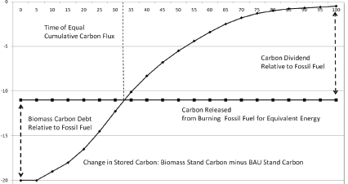
Figure 10. Incremental carbon storage (in tonnes) for a forest stand scenario compared to fossil fuel combustion.
Source: Walker et al. 2013. Note: BAU represents a typically harvested stand

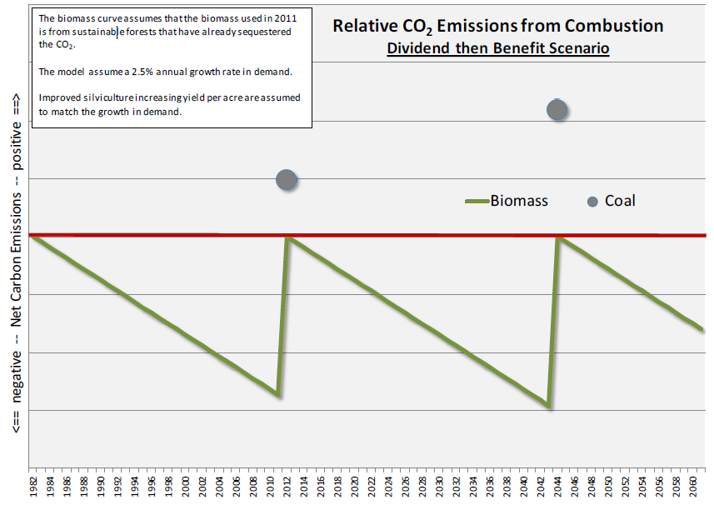
Figure 11. Incremental carbon storage and associated emissions in sustainably harvested forests.
Source: Strauss, 2011.

In the “debt-then-dividend” perspective (Walker et al., 2013), the timeline for the carbon accounting starts when a tree is harvested. In the dividend-then-benefit perspective (Strauss, 2011), biomass that is selectively harvested from existing forests that will be sustainably managed in the future, does not deplete the net stock as long as the growth-to-harvest ratio is greater than one. Therefore, no carbon debt is incurred.

Argonne National Laboratories (2018) analyzed carbon dynamics for a stand-level framework compared to a landscape-level dynamic framework and concluded that a landscape-level analysis is appropriate for conducting LCAs of products from managed forest with sustainable forestry management goals, i.e., a steady supply of forest biomass to customers and steady revenue to the respective landowner. They also found that slower-growing forestry-derived bioenergy feedstocks have larger variations in GHG emissions compared to short-rotation woody crops (SRWCs) that have relatively shorter growth cycles and faster growth rates, and that the increased elapsed time between biomass growth and biofuel combustion may weaken the assumption of carbon neutrality.

Dale et al. (2017) analyzed fuelsheds in southeastern (SE) United States, and demonstrated significant increases in timberland volume, acreage of large trees, harvestable carbon or all carbon pools following the expansion of woody pellet export beginning in 2009. They concluded that despite its growth in the region, the wood pellet industry, when employing sustainable forest management practices, has accrued environmental benefits- providing a pathway to reduce GHG emissions while retaining land in forests that provide ecosystem services - and that urbanization is the greatest cause of forest loss in the SE.

Life cycle analysis carbon accounting approaches using GREET inputs (Argonne National Laboratory, 2019) are discussed below.

Scenarios for GHG Impacts
In this Study, we examine multiple scenarios. The baseline scenario includes using fossil fuels (e.g. heating oil and natural gas) for residential heating, and woody biomass either remains in the forest or is sent to a landfill. The five bioenergy scenarios include utilizing different sources of woody biomass to produce wood pellets and chips that are substituted for fossil fuels.

Baseline Scenario
The baseline scenario represents the current situation in which heating oil and natural gas are used as sources of residential heating in the Northeastern US. In this scenario, if tree residues and slash are not harvested, and remain in the forests, they will decompose and slowly release CO₂ and methane, or possibly burn during wildfires and release a broader spectrum of GHG mature forests reach a growth to mortality equilibrium and no longer sequester additional carbon (Jiang et al., 2020; Pukkula, 2017); excess biomass in the forests that have not been burning under a natural fire regime increase the likelihood of wildfires that ultimately reduce forest carbon stock and produce GHG emissions.

Bioenergy Scenarios
In the bioenergy scenarios, the five different sources of woody biomass, described below, are collected and used to produce wood pellets and wood chips. Part of the fossil fuel load is replaced with wood pellets and chips, and the impacts of bioenergy usage in residential heating on GHG emissions are assessed.
- Wood pellets/chips are produced in the Northeast using forest residue collected from the Northeast.
- Wood pellets/chips are produced in the Northeast using lumbermill waste (sawdust, slabs) from the Northeast.
- Wood pellets/chips are produced in the Northeast using urban wood waste collected from the Northeast.
- Wood pellets/chips are produced in the Pacific Northwest using pine trees killed by pine beetles. The wood pellets/chips are then shipped to the Northeast.
- Wood pellets/chips are produced in the southeast using hog fuel/pulp tree cultivated in the Southeast. The wood pellets/chips are then shipped to the Northeast.

Data Sources
Calculations of life cycle GHG emissions are based on the energy inputs and emissions for each step in the wood pellet and wood chip production process. The data sources for direct emissions, wood pellet and wood chip production, and inputs for the upstream and downstream emissions in the life cycle are described below.

Wood Pellets and Chips Production Energy Inputs

Logging and Feedstock Collection
The feedstock inputs include fertilizer application, and lumber harvesting activities. Fertilizer input values (Argonne National Laboratories, 2019; Wells and Allen, 1985) are listed in Table 8.

Table 8. Feedstock Fertilizer Inputs.
Source | GREET1_2019 |  |  |  |  |  | Wells, 1985
 | Willow | Poplar | Forest Residue | Clean  Pine |  | Low |  | High
Farming or Collection Energy Use: Btu | 185,416 | 268,597 | 132,180 | 144,177
Fertilizer Input per Dry Ton Harvested/Collected
Grams of Nitrogen | 1,462 | 1,970 |  | 2,840 |  |  | 2,018 |  | 1,135
Grams of P₂O₅ | 650 | 591 |  | 1,523 |  |  |  |  | 568
Grams of K₂O | 1,002 | 522 |  | 401
Grams of CaCO₃ | 0 | 23,237 |  | 16,619
Pesticide Use
Grams of Herbicide | 16.1 | 61.7 |  | 0 |  |  | 0 |  | 0
Grams of Insecticide | 0.0 | 11.8 |  | 0 |  |  | 0 |  | 0
Low corresponds to low application rate, low yield; High Corresponds to high application high yield.
Source: Argonne National Laboratories (2019), and Wells and Allen, 1985.

Lumber harvesting activities typically include harvesting the trees with harvesting equipment (chainsaws or mechanical felling machines) and moving the logs to a central location (skidding). The equipment used here predominantly runs on diesel. Gasoline-powered chain saws are not typically used in Northeast logging operations because commercial scale logging equipment provides greater productivity and safety than traditional methods in this heavily forested region. The portion of the tree that is converted to biomass feedstock is chipped on-site and then transported for biomass energy or pulp/paper operations. Innovative Natural Resource Solutions LLC (2008) examined the energy inputs required for biomass production. Their study estimated the diesel energy inputs for commercial logging operations and forest residue collection based on surveys of 5 major contractors operating in the Northeast states. INRS’s energy input in Btu of diesel per ton of biomass is presented at the bottom of Table 10, based on the fuel use in gallons. The level of activity was estimated to be similar for large scale logging and selective forest thinning, as the size of the tree parts are relatively large diameter (3 to 6 inches). Energy use for reforestation is not accounted for in this Study, as the emissions associated with this activity are beyond the System Boundary Diagram (Figure 5), and are associated with the commercial logging operations. These energy inputs are consistent with the data in the GREET model (Table 9), which provide the primary basis for fuel use for feedstock collection in this Study.

Estimates of the energy inputs to handle lumber mill waste are also indicated (Table 10). The portions of the log that are not converted to lumber still require handling and chipping and a preliminary estimate of the energy requirements is the same as that for forest residue. Of course, the alternative fate of the lumber mill waste could also be considered. Mill residues can be stored in debris piles for many years, and even this activity requires energy. Kingsley (2008) found that most of the energy used to process wood chips was diesel fuel. All of these sources help assess the energy required for feedstock collection.

Table 9. GREET Data for Diesel Consumption for Wood Feedstock
Biomass Type |  | Btu/dry ton | gal/ton | MC | gal/AR ton
Willow |  | 185,000 | 1.44 | 50% | 2.88
Poplar |  | 268,597 | 2.09 | 50% | 4.18
Forest Residue |  | 132,180 | 1.03 | 50% | 2.06
Construction Waste |  | 408,068 | 3.18 | 15% | 3.74

Table 10. Diesel Inputs for Forestry and Estimates for Lumber Mill Operations.
Activity | Forest Residue | Lumber Mill Waste | Units
Felling & Skidding | 0.6 | 0 | gal/green ton
Landing, yarding, sorting, handling | 0.25 | 0.25 | gal/green ton
Chipping | 0.42 | 0.42 | gal/green ton
Total | 1.27 | 0.67 | gal/green ton
Total | 2.31 | 1.22 | gal/dry ton
Total | 294,326 | 155,274 | Btu/dry ton
Source: Kingsley, 2008.

The energy requirements processing forest residue specified by Kingsley (2008) correspond to about twice the GREET default value and are slightly higher than the default value for harvesting energy crop trees (234,770 Btu/dry ton). Since the Kingsley (2008) data is based on a survey of actual operating data in the Northeast region, these estimates seem appropriate as inputs for the life cycle analysis of forest residues.

The appropriate energy inputs for the life cycle analysis are 100% diesel for the feedstock harvesting and collection and transport. New pellet mills tend to be equipped with electric-powered motors for operating the mechanical equipment. Yard equipment would be diesel-fueled, so the energy inputs for pelletizing operations would be a combination of diesel fuel and electricity along with the fuel for drying the wood before pelletizing.

Moisture content of biomass varies depending on biomass type and is an important input parameter in the energy calculations for wood pelletization (Appendix A, Figure 12). The wood pelletization production process requires energy to dry biomass feedstock to a production-acceptable level. Prior to pelletization, feedstock is stored on-site, and typically loses some moisture during that storage timeframe. Drying energy is additionally applied to dry feedstock to the level required by pelletization equipment. Pellet production from dried feedstock is assumed to be the same across different feedstocks.

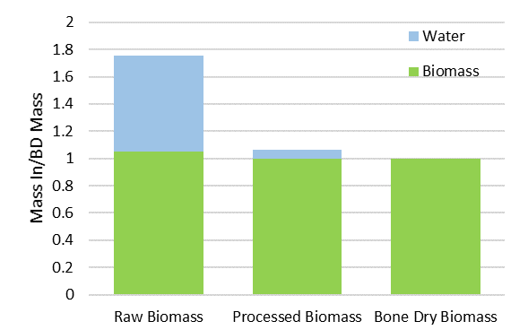
Figure 12. Relative moisture content of different states of woody biomass.

Alternative Fates.
In this section the emissions-relevant alternative fates of woody biomass sources (Table 4), when they are not manufactured into wood pellets, is presented in relation to the four reference systems presented in Figure 5. The issues associated with these alternative fates are similar, largely related to the production of GHG via decomposition of woody biomass.

Reference System 1: Saw Dust/Slash Pile to Decomposition
In this scenario, saw dust and slash that accumulates in piles becomes a source of GHG, primarily carbon dioxide while in an aerobic environment, but decomposing to methane once exposed to an anaerobic environment (California Air Resources Control Board, 2018; EPA, 2006; Pier and Kelly, 1997).

Reference System 2: Damaged Forest to Wildfire/Decomposition
Similarly, woody material in forests that is damaged due to factors including disease, insect infestations and extended drought can lead to considerable fuel loads that either decompose and produce carbon dioxide and/or methane, or are ignited through controlled burns or wildfires and emit a wider range of GHG and PM.

Reference System 3: Urban Wood Waste to Landfill:
Wood waste associated with urban development is sent to landfills where it occupies space, and decomposes, releasing carbon dioxide and/or methane (California Air Resources Control Board, 2018; IPCC, 2000). Much of the urban waste wood is treated with some forms of lacquers, preservatives, or paints, containing potential pollutants, and therefore, these wood types are not allowed for use as heating fuel. Sourcing urban wood waste for pellet production, therefore, must be done carefully to select material that is free of paint and laquers that contain pollutants.

Urban wood waste faces another challenge for use under the RFS because proving its source, and that it did not originate from a national forest or other protected land, is bound to be challenging in most situations.

Reference System 4: Planted Trees to Pulp and paper/Wood Products
Softer woods and smaller diameter material are typically sourced from tree plantations for pulp and paper products. By design, tree plantations are meant to be actively managed and harvested and lack the diverse structure and function of natural forests. Left unmanaged, these plantations can become overcrowded, creating high fuel loads and high risk for disease and fire. Left unburned, dead woody biomass decomposes, producing carbon dioxide in an aerobic environment and/or methane in an anaerobic environment.

Wood Chips and Pellets Transport Parameters
Transport of biomass was estimated using an 18-ton heavy-duty truck moving feedstocks with respective moisture contents (as-received/green ton basis) and yielded a similar energy intensity input (Btu/dry ton-mi) as the GREET default inputs. Transport distances can vary greatly and are site specific. In this Study, two phases of transport were modeled: distance travelled from the feedstock source to a chipping or pelleting plant, and distance travelled from the chipping or pelleting plant to market. For each feedstock, a 50 or 90-mile transport distance via truck was used to model transport emissions to a wood chip or pellet plant depending on the location of the feedstock. Feedstocks requiring transport from a forest, e.g., forest residue and pine-beetle-infested, were assigned a 90-mile transport distance to mills, and a shorter 50-mile transport distance to mill was assigned to the other three feedstocks. It was assumed that pellets are more likely to be shipped for greater distances due to their higher energy and market value. Therefore, for the three feedstocks (lumber mill waste, forest residue, and urban wood waste) that can reasonably occur within New England, a 250-mile transport distance via truck was used to model transport emissions from the pellet plant to market, and 70-mile transport distance via truck was used to model transport emissions from a wood chip plant to market. For feedstock derived from pine-beetle-infested wood from the western U.S., a 2,500-mile train transport distance was used to model transport emissions to market. For hog fuel/pulp feedstock derived from farmed trees in the southeastern U.S., a 1,100-mile train transport distance was used to model transport emissions to market.

Table 11 presents direct input parameters (upper segment of table) and calculated parameters (lower part of table) for all transport scenarios relevant to the wood pellet pathway. Detailed model results are included in Appendix A.
Table 11. Woody Biomass Feedstock Parameters for Transport to Pelletizing Plants and Associated GHG Emissions.
ª 50% for Forest Residue and Hog Fuel/Pulp Chip feedstocks;
40% for Lumbermill Waste feedstock; 25% for Pine Beetle-Infested Feedstock;
15% for Urban Wood Waste feedstock.
^{b} 50 miles for Lumbermill Waste, Urban Wood Waste, and Hog Fuel/Pulp Chip feedstocks;
90 miles for Forest Residue and Pine-Beetle-Infested feedstocks

Electric Power Generation
GHG emissions are calculated with the GREET model (ANL 2019) upstream emission factors using the resource mix for northeast (6-NPCC mix). The resource mix for southeast (8-SERC mix) was also used due to its high share in wood pellet and wood chip production.

Heating Oil and Natural Gas Upstream Emissions
Currently, consumption of heating oil and natural gas for residential heating is a common practice in the Northeast and the purpose of this Study is to analyze the environmental impacts of current fossil fuels and their renewable alternatives (wood pellets and wood chips).

In this Study, the emission factors of diesel were used for heating oil (Table 11). The GHG emissions of diesel are divided into two groups, upstream emissions which is from crude oil to diesel and emissions resulted from burning the fuel. The GREET model estimates the emissions from crude oil to petroleum fuels based on the complexity of the oil refineries in different regions of the U.S. Among other parameters the GHG emissions from a refinery are directly related to the density of crude oils measured in API gravity. Crude oils that are light (higher degrees of API gravity or lower density) tend to require less intensive processing which results in lower GHG emissions. Similarly, natural gas has upstream emissions resulting from extraction and delivery of natural gas and emissions from burning natural gas (Table 12).

Table 12. GREET Upstream Emissions for Heating Oil and Natural Gas.
 | GREET1_2019 |  |  |  | GREET_1.8c
 | Natural gas |  | Heating oil |  | Natural gas |  | Heating oil
gCO₂e/MMBtu | Upstream Emissions | Fuel Burning | Upstream Emissions | Fuel Burning | Upstream Emissions | Fuel Burning | Upstream Emissions | Fuel Burning
VOC | 10.320 | 2.540 | 7.657 | 0.800 | 5.827 | 1.557 | 7.683 | 1.173
CO | 31.994 | 22.210 | 12.773 | 20.867 | 8.010 | 16.419 | 12.219 | 16.686
NO_{x} | 40.003 | 36.400 | 26.523 | 53.860 | 22.825 | 57.607 | 41.532 | 82.225
PM10 | 0.473 | 3.507 | 1.790 | 8.122 | 0.878 | 3.206 | 8.042 | 42.530
PM2.5 | 0.421 | 3.507 | 1.502 | 5.473 | 0.521 | 3.206 | 3.237 | 38.000
SOx | 11.551 | 0.269 | 9.983 | 0.542 | 11.573 | 0.269 | 19.855 | 8.038
BCª | 0.132 | 0.579 | 0.261 | 0.547
OC^{b} | 0.151 | 1.501 | 0.445 | 1.368
CH₄ | 219.231 | 1.060 | 111.644 | 0.198 | 196.356 | 1.100 | 103.396 | 0.180
N₂O | 1.416 | 0.750 | 0.230 | 0.918 | 0.087 | 1.100 | 0.233 | 0.390
CO2 | 6,066 | 59,367 | 13,527 | 78,163 | 5,258 | 59,379 | 14,416 | 78,169
CO₂ (w/ C in VOC & CO) | 6,149 | 59,410 | 13,571 | 78,199 | 5,288 | 59,410 | 14,459 | 78,199
GHG | 13,101 | 59,640 | 16,981 | 78,448 | 10,223 | 59,765 | 17,113 | 78,319
ª Black Carbon, this pollutant is a contribution to global warming and counted in GREET but is not part of the analysis for the RFS2.
^{b} Organic Carbon

LCA Results

Wood Pellets and Chips LCA
The GHG emissions of wood pellets and wood chips produced from various sources including , lumbermill waste, forest residue, urban wood waste, pine beetle-infested and pulp wood were estimated using GREET1_2019 model and the results are presented in Table 13 and Table 14. The conversion efficiencies of these fuel alternatives were not explored in this Study.
Table 13. GHG Emissions of Wood Pelletsª
GHG (gCO₂e/MJ) | LumberMill Waste | Forest Residue | Urban Wood Waste | Pine Beetle | Pulp Chips
Collection and Transportation
Farming | 0 | 0 | 0 | 0 | 0.23
Collection | 0 | 1.97 | 3.30 | 1.01 | 2.21
Transportation | 0.76 | 1.42 | 0.65 | 1.31 | 1.14
Pelletizing Plant
Diesel | 0.37 | 0.38 | 1.66 | 0.36 | 0.37
Electricity | 1.96 | 2.51 | 2.36 | 2.35 | 2.44
Transportation to Market | 2.88 | 2.95 | 2.77 | 3.80 | 1.74
Burning Emissions, CH₄ and N₂O | 2.17 | 2.23 | 2.09 | 2.08 | 2.17
Total | 8.32 | 11.45 | 12.82 | 10.91 | 10.31
ªEmissions are on a net carbon neutral basis assuming that biogenic CO₂ is removed from the atmosphere with no storage effect. There the biogenic uptake and reforestation as well as changes in forest growth are not show here.
Table 14. GHG Emissions of Wood Chips
GHG (gCO₂e/MJ) | Lumber Mill Waste | Forest Residue | Urban Wood Waste | Pine Beetle | Pulp Chips
Collection and Transportation
Farming | 0 | 0 | 0 | 0 | 0.62
Collection | 0 | 1.88 | 3.27 | 1.18 | 3.01
Transportation | 0.91 | 1.31 | 0.58 | 1.22 | 0.77
Pelletizing Plant
Diesel | 0.16 | 0.19 | 0.75 | 0.18 | 0.20
Transportation to Market | 0.85 | 1.02 | 0.81 | 0.95 | 1.08
Burning Emissions | 2.28 | 2.74 | 2.19 | 2.57 | 2.91
Total | 4.19 | 7.13 | 7.60 | 6.09 | 8.59

The GHG emissions of wood chips are lower than those of wood pellets largely due to the lower energy consumption during wood chipping compared to wood pelletization. Figure 13 shows the contribution of each stage of wood pellet/chips production in total CI of wood pellets/chips. While the pelletization stage has the highest contribution in wood pellet CI, transportation and stove emissions generated the highest emissions in wood chips production.
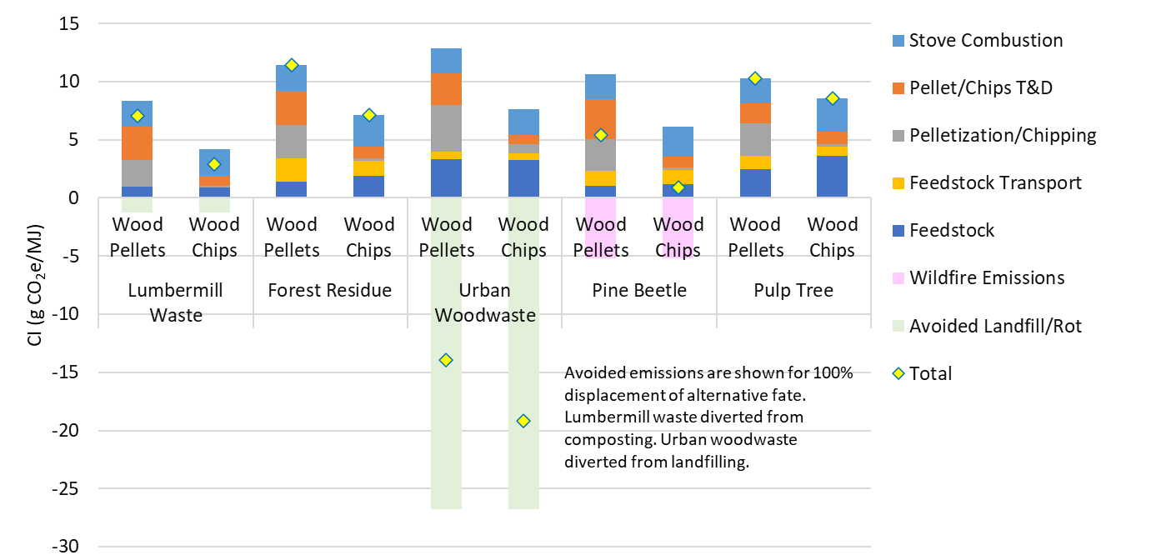 Figure 13. GHG Emissions of Wood Pellets and Wood Chips from specified woody biomass feedstocks.
Note: T&D refers to transport and drying.

For combustion emissions, the combusting wood pellets/chips are treated on a carbon neutral basis. Meaning. Biogenic CO₂ emission resulted from burning of wood pellet/chips were recently removed from the atmosphere and will be captured when biomass is grown sustainably. Therefore, only methane and nitrous oxide emissions contribute to direct GHG emissions from combustion, based on the pollutants counted under the RFS2.

Heating Oil and Natural Gas LCA
The GHG emissions of natural gas and heating oil as two major fuels for residential heating were calculated using GREET1_2019 and GREET_1.8c and shown in Table 15. Note that the emissions listed in Table 15 include both upstream emissions and stove emissions. Natural gas has a lower carbon intensity (CI) than heating oil and its use is increasing relative to heating oil. Approximately 20% of households in the Northeast US Census region used heating oil as their primary space heating fuel, accounting for 82% of US households using heating oil for space heating (US EIA, 2020).
Table 15. GHG Emissions of Heating Oil and Natural Gas
 | GREET1_2019 |  | GREET_1.8c
 | Natural Gas | Heating Oil | Natural Gas | Heating Oil
Upstream Emissions (gCO₂e/MMBtu) | 13,101 | 16,981 | 10,223 | 17,113
Burning Emissions (gCO₂e/MMBtu) | 59,640 | 78,448 | 59,765 | 78,319
Total (gCO₂e/MMBtu) | 72,741 | 95,429 | 69,988 | 95,432
Total (gCO₂e/MJ) | 68.95 | 90.45 | 66.34 | 90.45

Scenario Analysis
After conducting the LCA for baseline scenario, in which fossil fuels such as heating oil and natural gas are used for residential heating, and bioenergy scenarios in which woody biomass are converted to wood pellets/chips and the energy used for residential heating, the CI of each case was compared (Figure 14). The CI of natural gas and heating oil is much higher than their renewable alternatives. Thus, replacing heating oil and natural gas with wood pellets or wood chips can save significant amounts of GHG emissions.

Figure 14 illustrates the cradle to boiler emissions as well as avoided emissions associated with each woody biomass feedstock relative to emissions associated with heating oil and natural gas. Note that not collecting forest residues, slash piles and pines killed by pine beetle may increase the risk of wildfire. For some scenarios such as wood pellets/chips from forest residue and beetle-killed pine, it is reasonable, therefore, to not account for stove emissions, since the aforementioned increase the risk of wildfire and generate emissions equal to or greater than stove emissions. In this case, the CI of wood pellets/chips is even lower than current estimates.

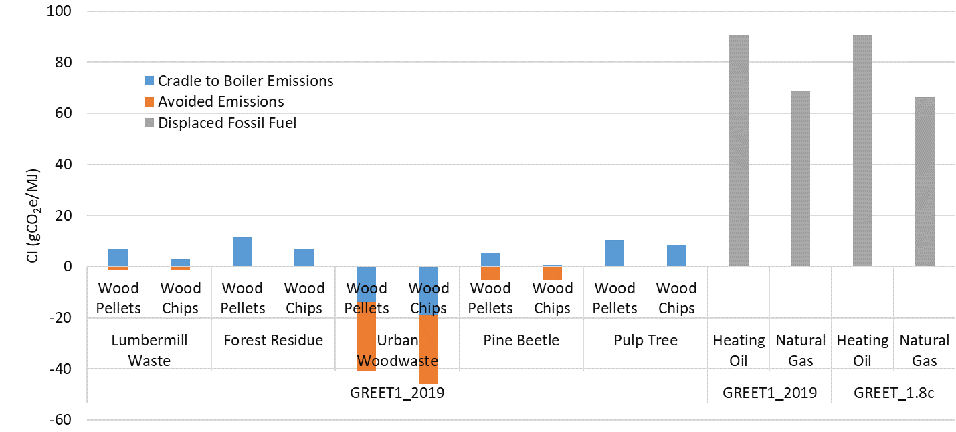
Figure 14. CI of Heating Oil and Natural Gas and their Renewable Alternatives.

Carbon Credit Programs
Aside from EPA RFS2 program, there are other programs such as the California Low Carbon Fuel Program (LCFS) that allows biofuel developers to generate credits if biofuel is shipped and used in California.

California Low Carbon Fuel Standard
In 2009 the California Air Resource Board approved the LCFS regulation to reduce the CI of transportation fuel used in California by at least 10 percent by 2020 from a 2010 baseline (Error! Reference source not found.). The LCFS requires biofuel developers to measure the CI of their biofuel since the LCFS credit is based on the difference between the CI of biofuel and CI of baseline fossil fuel and varies over time based on market demand. The LCFS sets annual CI standards, or benchmarks, which reduce over time, for gasoline, diesel, and the fuels that replace them. The LCFS also requires that the biofuel is used in the transportation sector. Using biomass-generated electricity to charge electric vehicles and earn LCFS credits is potentially an option. The power must be generated in California to generate credits for electric vehicle (EV) operation in the state.

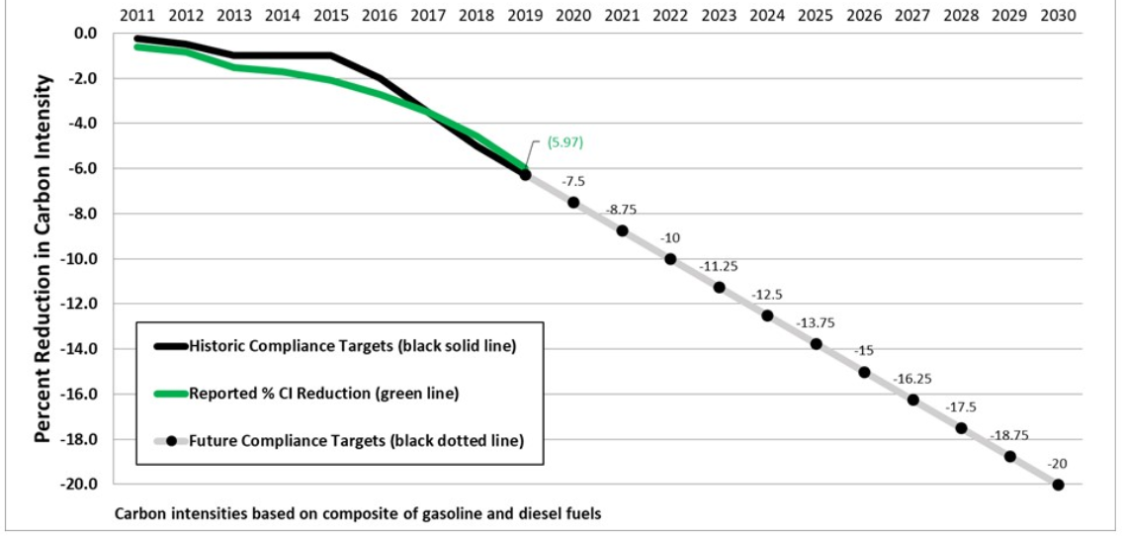
Figure 15. Performance targets for the California Low Carbon Fuel Standard.
Source: California Air Resources Control Board, 2020.

While process heat is not treated as a transportation fuel under the LCFS, the use of biomass that displaces natural gas as process heat in a fuel pathway would increase LCFS credit generation. For example, if a biodiesel plant that uses 150 MMBtu/month of natural gas switched to wood pellets with a CI of 12 g CO₂e/MJ, the facility would reduce GHG emissions by 8.1 tonne CO₂e per month and increase credit revenue by $1,630 at a value of $10.9/MMBtu. This revenue would vary with credit price. Recent history is shown in Figure 16.

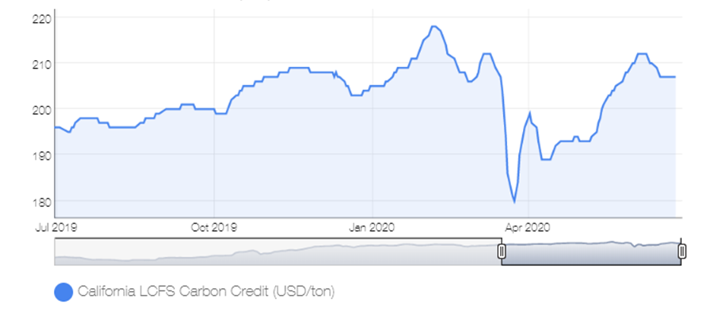
Figure 16. Price (USD) per ton for credits generated by the California Low Carbon Fuel Standard.
Source: Neste, 2020.

Voluntary Credit Programs
Voluntary carbon markets provide an opportunity for entities that are unable to reduce their emissions to purchase carbon credits from verified suppliers to offset their emissions. The revenues collected are used to finance carbon reduction projects. Voluntary credit buyers are often driven by certain considerations such as safeguarding their reputation, ethics, and corporate social responsibility (CSR). The value of GHG reductions in voluntary markets is typically below $10/tonne of GHG emissions compared to approximately $190/tonne for the LCFS, which aims to motivate change in the transportation sector.

Renewable Fuel Standard
If biomass based thermal energy were included under the RFS2, it would presumably generate a D3 RIN. These RINs are valued at about $1/RIN (Figure 17). For 1 MMBtu, HHV basis or 950,000 Btu, LHV-basis would generate 12 RINs or $190 per ton of biomass (dry basis). Effectively this could lower the net cost of a ton of wood pellets to $60/ton of biomass (dry basis).

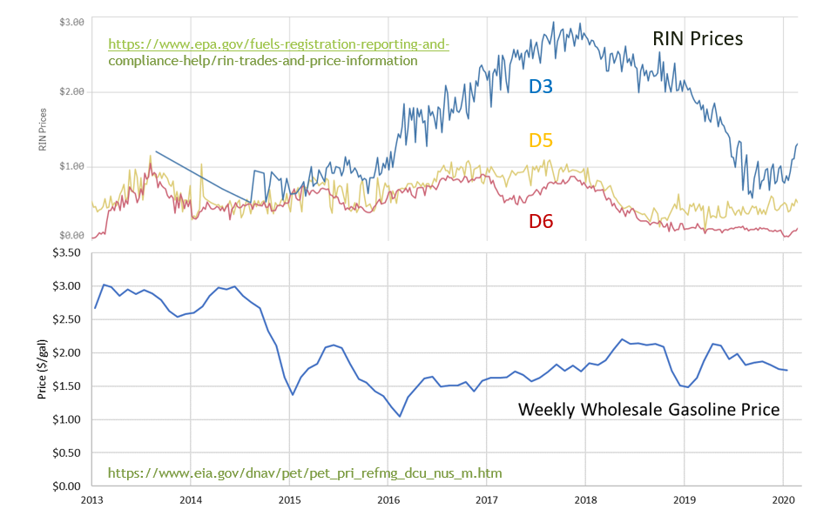
Figure 17. Value of renewable identification number (RIN) credits generated under the Renewable Fuel Standard.
Source: EPA, 2020

Table 16 illustrates the relative value of woody biomass fuel under the RFS, as a heating fuel, and under the LCFS, as a process fuel. This example assumes market values that have recently been associated with the RFS and the LCFS, and illustrates an approximate $84 valuation difference.

Table 16. Comparison of Valuation of Woody Biomass Fuel as Heating Fuel Under the RFS and as Process Fuel Under the LCFS.

Conclusions
In this study, the possibility of adding thermal conversion of biomass for residential heating to RFS was assessed. Heating oil and natural gas are two major sources of energy for residential heating in the Northeast. Wood pellets and wood chips are two renewable substitutes for heating oil and natural gas. Wood pellets and wood chips are made from various waste sources such as lumbermill waste, forest residue, and urban wood waste that would otherwise generate GHGs either through the process of decomposition or burning. LCA results showed that the CI of wood pellets/chips from all biomass sources considered in this study was significantly lower than that of fossil heating oil and natural gas (without considering the conversion efficiencies), indicating that wood pellets/chips are a promising alternative for heating oil and natural gas.

Since wood pellets/chips are made from pulpwood and waste biomass such as lumbermill waste and forest residue, and they have a significantly lower CI compared to heating oil and natural gas, EPA needs to reevaluate the RFS and consider creating a pathway for thermal conversion of biomass from federal and non-federal lands as residential heating energy.

References

Argonne National Laboratory. 2018. Carbon Dynamics for Biofuels Produced from Woody Feedstocks. ANL/ESD-18/10.
Argonne National Laboratory. 2019. GREET1_2019 Life Cycle Greenhouse Gas for Transportation Model, Argonne National Laboratory.
Ibid. 2009. The Greenhouse Gases, Regulated Emissions, and Energy Use in Transportation (GREET) Model, Version 1.8c.0. ANL, DOE. http://www.transportation.anl.gov/modeling_simulation/GREET/index.html.
Badger, P. 2002. Processing Cost Analysis for Biomass Feedstocks. Prepared for the U.S. Department of Energy Office of Energy Efficiency and Renewable Energy Biomass Program. Prepared by Oak Ridge National Laboratory. Contract DE-AC05-00OR22725.
Biomass Magazine. 2020. Wood Pellet Plant Sale Advertisement. Ontario Logs & Lumber Ltd. Accessed 8.4.2020.
Brackley, Allen M., Maureen Nicholls, David L. Puettmann, & Elaine Oneil. 2017. Life Cycle Assessment of Wood Energy for Residential Heating—Opportunities for Wood Pellet Production in Southeast Alaska.
Buchholz T, Gunn JS, & Saah, DS. 2017. Greenhouse gas emissions of local wood pellet heat from northeastern US forests, Energy. Doi: 10.1016/j.energy.2017.09.062.
California Air Resources Control Board. 2020. Data Dashboard. https://ww3.arb.ca.gov/fuels/lcfs/dashboard/dashboard.htm. Accessed 6.25.20.
California Department of Resources Recycling and Recovery (Cal Recycle). 2020. https://www.calrecycle.ca/gov/ConDemo/. Accessed 8.5.2020.
Climate Impacts Group University of Washington. 2013. Climate Change Impacts and Adaptation in Washington State: Technical Summaries for Decision Makers. (December):1–128.
Collins, B.J., C.C. Rhoades, M.A. Battaglia, & R.M. Hubbard. 2012. The effects of bark beetle outbreaks on forest development, fuel loads and potential fire behavior in salvage logged and untreated lodgepole pine forests. Forest Ecology and Management. Doi.org/10.1016/j.foreco.2012.07.027.
Congressional Research Service. 2019. Wildfire Statistics. Updated October 3, 2019.
Dale, VH, E. Parish, KL Kline, and E. Tobin. 2017. How Is Wood-Based Pellet Production Affecting Forest Conditions in the Southeastern United States? Forest Ecology and Management 396:143–49.
Donovan, C.T. & Associates, 1994, A Sourcebook on Wood Waste Recovery and Recycling in the Southeast, U.S. Department of Energy Southeastern Regional Biomass Energy Program, Tennessee Valley Authority, Muscle Shoals, Alabama.
Federal Register. 2019. Renewable Fuel Standard Program: Standards for 2020 and Biomass-Based Diesel Volume for 2021, Response to the Remand of the 2016 Standards, and Other changes. A Proposed Rule by the Environmental Protection Agency on 7/29/2019. Accessed 6.25.20.
EPA. 2006. Solid waste management and greenhouse gases: a life cycle assessment of emissions and sinks.
EPA. 2010. Renewable Fuel Standard Program (RFS2) Regulatory Impact Analysis. EPA-420-R-10-006.
EPA. 2013. 40 CFR Part 80 Regulation of Fuels and Fuel Additives: 2013 Renewable Fuel Standards. EPA-HQ-OAR-2012-0546; FRL-9834-5. RIN 2060-AR43.
IEA Bioenergy. 2018. Is Energy from Woody Biomass Positive for the Climate? https://www.ieabioenergy.com/wp-content/uploads/2018/01/FAQ_WoodyBiomass-Climate_final-1.pdf
Garzon, A.R.G., P. Bettinger, J. Siry, J. Abrams, C. Cieszewski, K. Boston, B. Mei, H. Zengin, and A. Yesil. 2020. A comparative analysis of five forest certification programs. Forests 11:863. www.mdpi.com/journal/forests. Doi:10.3390/f11080863.
INRS. 2008. Status of Northern Forest Region States’ Forestry and Forest Products Industry. A report to the Northern Forest Center and North Country Council.
IPCC. 2018. Summary for Policymakers, Global Warming of 1.5°C, An IPCC Special Report on the impacts of global warming of 1.5°C above pre-industrial levels and related global greenhouse gas emission pathways, in the context of strengthening the global response to the threat of climate change, sustainable development, and efforts to eradicate poverty. Prepared by the World Meteorological Organization, Geneva, Switzerland.
IPCC. 2000. Good Practice Guidance and Uncertainty in National Greenhouse Gas Inventories. Chapter 5 Waste.
ISO. 2006. ISO 14040:2006 Environmental Management -- Life Cycle Assessment -- Principles and Framework edited by E. M. 2006.
Jiang, M., B. Medlyn, and D.Ellsworth. 2020. The fate of carbon in a mature forest under carbon dioxide enrichment. Nature 580:227-231.
Kim, Sei Jin, Justin S. Baker, Brent L. Sohngen, & Michael Shell. 2018. Cumulative Global Forest Carbon Implications of Regional Bioenergy Expansion Policies. Resource and Energy Economics 53:198–219.
Kingsley, E. 2008. Diesel Inputs for Logging and forestry Operations. Innovative Natural Resources Solutions, Inc., personal communication, http://www.inrsllc.com/.

Murphy, Fionnuala, Ger Devlin, and Kevin McDonnell. 2015. “Greenhouse Gas and Energy Based Life Cycle Analysis of Products from the Irish Wood Processing Industry.” Journal of Cleaner Production 92:134–41.
Myhre, Gunnar, Drew Shindell, Francois-Marie Bréon, William Collins, Jan Fuglestvedt, Jianping Huang, Dorothy Koch, Jean-Francois Lamarque, David Lee, Blanca Mendoza, Teruyuki Nakajima, Alan Robock, Graeme Stephens, Toshihiko Takemura, & Hua Zhang. 2013. Anthropogenic and Natural Radiative Forcing. Pp. 659–740 in Climate Change 2013 - The Physical Science Basis, edited by Intergovernmental Panel on Climate Change. Cambridge: Cambridge University Press.
Page, W.G., M.J. Jenkins, and M.E. Alexander. 2014. Models to Predict the Moisture Content of Lodgepole Pine Foliage During the Red Stage of Mountain Pine Beetle Attack. Forest Science (60). http://dx.doi.org/10.5849/forsci.13-206.
Pellet Fuels Institute. PFI Standards. https://www.pelletheat.org/joining-the-pfi-standards-program. Accessed 8.13.20.
Pier, P.A., J.M. Kelly. 1997. Measured and estimated methan and carbon dioxide emissions from sawdust waste in the Tennessee Valley under alternative management strategies. Biosource Technology 61:213-220.
Pukkala, T. 2017. Does management improve the carbon balance of forestry? Forestry: An International Journal of Forest Research 90:1:125-135. https://doi.org/10.1093/forestry/cpw043.
Quinteiro, P., Luís Tarelho, P. Marques, M. Martín-Gamboa, Fausto Freire, Luís Arroja, & Ana Cláudia Dias. 2019. Life Cycle Assessment of Wood Pellets and Wood Split Logs for Residential Heating. Science of the Total Environment 689:580–89.
Reijnders, L. 2006. Conditions for the sustainability of biomass-based fuel use. Energy Policy, 34(7): 863-876. http://dx.doi.org/10.1016/j.enpol.2004.09.001
Selavinovs, J. D. Blumberga, J. Ziemele, A. Blumberga, & A. Barisa. 2012. Research of Woody Biomass Drying Process in Pellet Production. Environmental and Climate Technologies. Doi: 10.2478/v10145-012-0017-7.
Scott L Stephens, Brandon M Collins, Christopher J Fettig, Mark A Finney, Chad M Hoffman, Eric E Knapp, Malcolm P North, Hugh Safford, and Rebecca B Wayman. 2018. Drought, Tree Mortality, and Wildfire in Forests Adapted to Frequent Fire. BioScience 68:2:77-88. https://doi.org/10.1093/biosci/bix146.
Strauss, W. 2011. Biomass Magazine.com. How Manomet Got it Backwards: Challenging the “Debt-then-Dividend” Axiom. http://biomassmagazine.com/articles/5621/how-manomet-got-it-backwards-challenging-the-undefineddebt-then-dividendundefined-axiom
Sustainable Forestry Initiative. 2019. Sustainable Forestry Standards and Certified Products. https://www.sfiprogram.org/standardguide2015-2019/. Accessed 6.21.20.
Thrän et al. 2017. Global Wood Pellet Industry and Trade Study 2017. IEA Bioenergy Task 40. June 2017.
Unnasch, Stefan, Louis Browning, & E. Kassoy. 2001. Refinement of Selected Fuel-Cycle Emissions Analyses. ARB Contract Number: 98-338. FR-00-101. California Air Resources Board. Sacramento, CA.
Unnasch, Stefan & Brent Riffel. 2009. Requirements for Developing a Low Carbon Fuel Standard for Northeast States.
US EIA. 2020. Heating oil explained. https://www.eia.gov/energyexplained/heating-oil/use-of-heating-oil.php. Accessed June 26, 2020.
Voegele, Erin. 2019. EIA: 2 Million Households to Heat with Wood this Winter. Biomass Magazine. October 9, 2019.
Walker, T., Cardellichio, P., Gunn, J.S., Saah, D.S., & Hagan, J.M., 2013. Carbon accounting for woody biomass from Massachusetts (USA) managed forests: a framework for determining the temporal impacts of wood biomass energy on atmospheric greenhouse gas levels. Journal of Sustainable Forestry. 32 (1–2), 130–158.
Warner, Daniel L., D., Samuel Villarreal, Kelsey McWilliams, Shreeram Inamdar, & Rodrigo Vargas. Carbon Dioxide and Methane Fluxes from Tree Stems, Coarse Woody Debris, and Soils in an Upland Temperate Forest. Ecosystems, 2017; DOI: 10.1007/s10021-016-0106-8.
Wells, Carol, and Lee Allen. 1985. A loblolly pine management guide, when and where to apply fertilizer. United States Department of Agriculture Forest Service, Southeastern Forest Experiment Station. General Technical Report SE-36.
Wyden, Ron. 2019. A Bill to Change the Definition of Renewable Biomass. Bill S. 1614.
EPA. 2020. https://www.epa.gov/renewable-fuel-standard-program/final-renewable-fuel-standards-2020-and-biomass-based-diesel-volume.

Appendices
Appendix A. Life Cycle Analysis Inputs and Results
Lumber Mill waste
Collection and Transportation-Lumber Mill Waste to Pelletizing/Chipping Plant |  | Pellets | Chips
Feedstock Moisture Content | % | 40% | 40%
Distance | mile | 50 | 50
Collection | gal/ton | 0 | 0
Transportation Mode | - | Truck | Truck
Pelletizing/Chipping Plant
Dry Matter Yield | ton fuel/ AR ton feedstock | 0.95 | 1
Feed to Product Ratio, AR | AR ton/ton product | 1.649 | 1.500
Biomass Heating Value, LHV | MMBtu/BD ton | 16.61 | 16.61
Heating Value of Pellet/Chip, LHV | MMBtu/ ton | 15.61 | 14.85
Moisture Content of Wood Pellets | % | 6% | 10%
Diesel | gal/ton | 0.5 | 0.2
Electricity | kWh/ton | 120 | 0
Natural gas | MMBtu/ton | 0 | 0
Transportation to Market
Distance | mile | 250 | 70
Transportation Mode | - | Truck | Truck
Sawdust and remnants from freshly milled logs. Source: https://www.futuremetrics.info/wp-content/uploads/2020/07/CO2Dash/CO2FootPrintDashboard.html

All GREET models are peer-reviewed and calculate life cycle emissions based on energy inputs.
This Study calculates the GHG reductions based on different displaced fuels. While natural gas is not considered a baseline fuel under the RFS, the comparison is still of interest.
See Reijnders (2006) for a discussion of sustainable forestry management practices.
Per Sustainable Forest Management Standards (Sustainable Forestry Initiative, 2019).
For example, consider electric cars with zero emissions during driving. The life cycle emissions including upstream emissions provide the relevant basis for comparison with other transportation options.
Direct-fired rotary drum dryers are prevalent drying system in the U.S., commonly using natural gas or electricity (Selivanovs et al., 2012) as well as woody biomass.
1 J = 1055.055 Btu
Combustion sources include boilers, fired heaters, power generation equipment and engines for transport.
Cradle to gate emissions are also referred to as well to tank or upstream life cycle. The term upstream life cycle is used in this Study. Fuel life cycle emissions are referred to as cradle to grave or well to wheels (or wake).
GREET inputs are typically in Btu/MMBtu (million Btu). However, the calculations are the same for a functional unit of one tonne of methanol with the appropriate unit conversions. The nomenclature here assumes appropriate unit conversions.
Also commonly referred to as the Manomet Study.
Results are not very sensitive to modeled assumptions.
The scope of this Study did not include comparing efficiencies of converting various fuel sources to useable energy.
(69-12) g/MJ savings, $200/tonne of CO₂.

